Kelsey Johnson, President | Blake Sequeira, Vice President
Bryan Jones, Treasurer | Elvira Fong, Board Member
Jason Walkup, Secretary | Colleen Mahlman, Board Member
Leonard Orman, Board Member | Donald “Reid” Smith, Board Member
Laurie Haugen, Board Member | Vanessa Stacholy, Board Member
Vacant, Board Member | Michelle Espy, Board Member
(Terms ending 6/2026) | (Terms ending 6/2027)

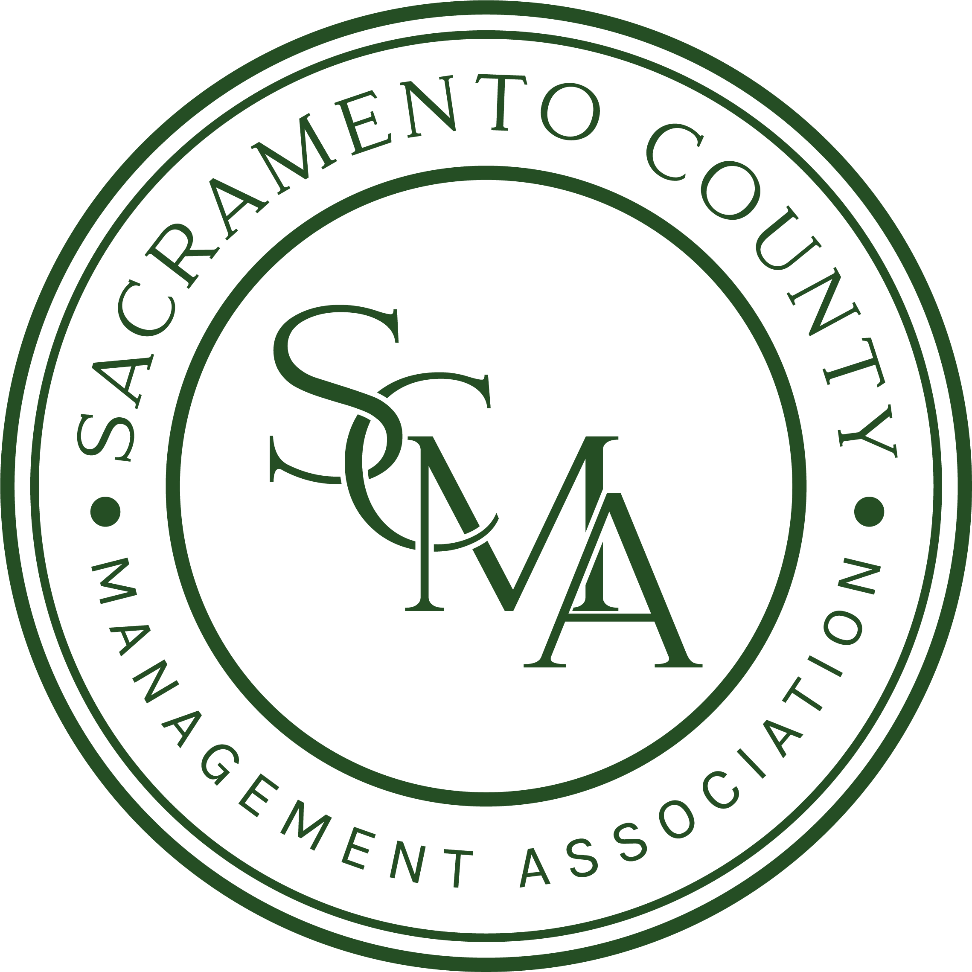

SCMA Board of Directors
January 7, 2026
Agenda

Members Present:
Recognition of Any Proxies:
Guest Introduction:
Meeting call to order at ______.
- Introduction & new business agenda items:

- Review and approve August 6, 2025, October 2025, and November 2025 meeting minutes.

- Treasurer’s Report

- Committee Reports

  - Association Meeting:
  - Bylaws:
  - Elections:
  - Website:
  - Membership:
  - Meet & Confer:
  - Discipline:
- Negotiations

- Correspondence

- Old Business:
  - Follow up on driver’s license for some job specifics

- Bank/CU account

- New Business:

Future SCMA board meetings

- Closed Session if necessary

- Adjourn- _____ p.m.

