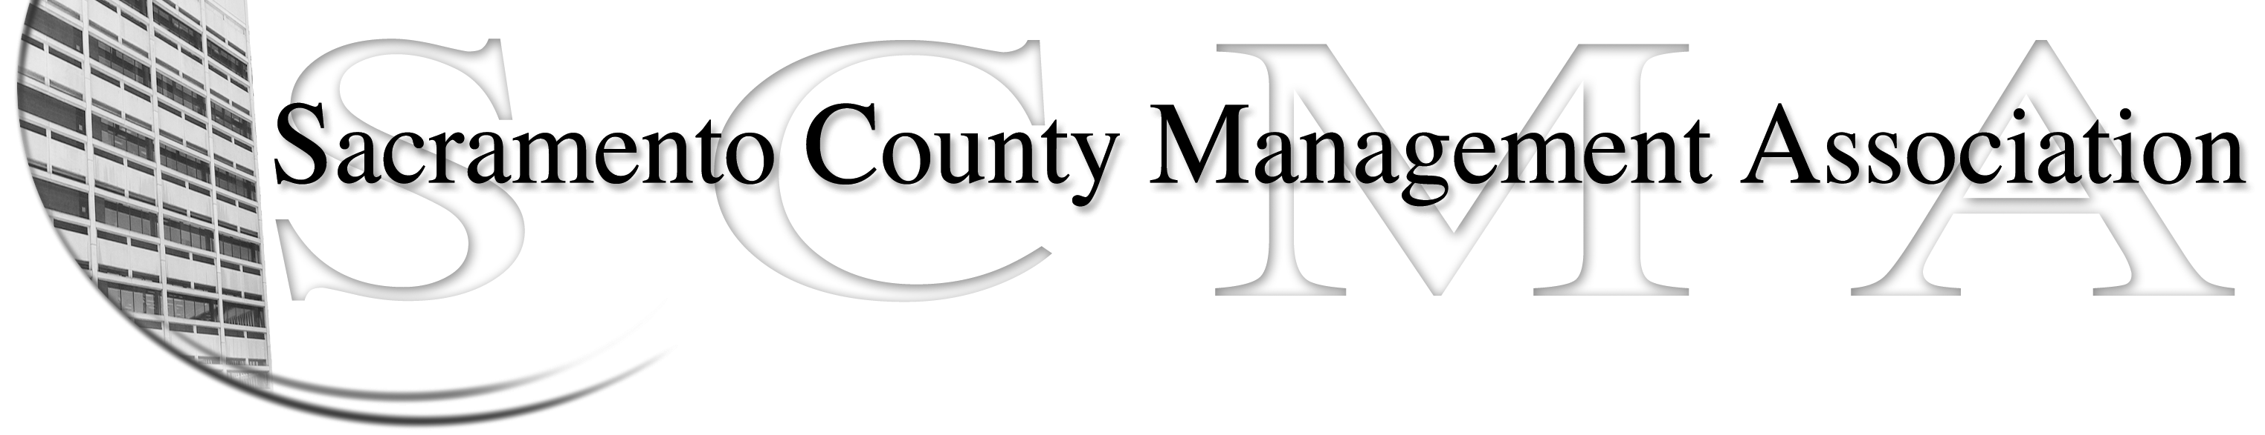

Phil Fiscbach, President |  | Nancy Gust, Board Member
Sue Elliott, Vice President |  | Mike Guiver, Board Member
RoseMary Vaske, Secretary |  | Robert Nelson, Board Member
Forrest Williams, Treasurer |  | Craig Rader, Board Member
Al Mateer, Past President |  | Brad Buyse, Board Member
 |  | Vacant

SCMA Board of Director’s Minutes

SCMA Board of Director’s Agenda
700 H. Street / 7th Floor Conference Room

September 15, 2009 – 9:30 A.M.

- Review and approve the Board minutes from the August 18, 2009 and the special meeting of September 9, 2009.

- Treasurer’s Report - Forrest
  - Financial report
  - Update 2008 tax return

- Committee Reports
  - Spring luncheon / summary – Sue
  - Fall luncheon / finalize the agenda – All
  - Subctte Update – CBM/bylaws - RoseMary

- Correspondence

- Old Business

A. Response to RFP – Craig
B. Webpage update – Craig
C. LTD / continue discussion on future of program - All
D. Meeting location - All

- New Business

- Adjournment

