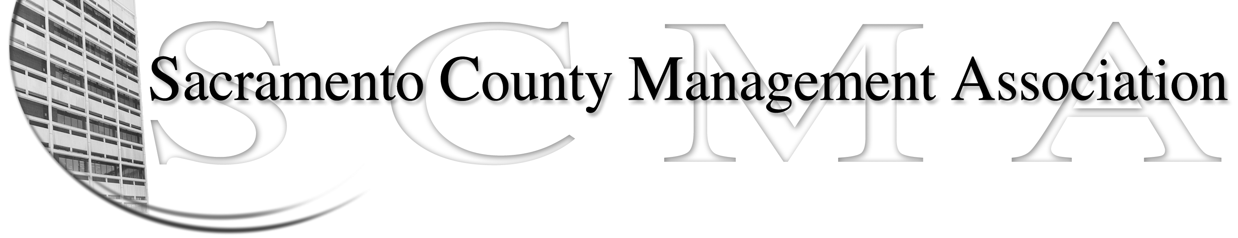

Kelsey Johnson, President Forrest Williams, Vice President
Nancy Gust, Secretary Jan Holm, Treasurer
Diana Ruiz, Board Member Darcy Moehring, Board Member Will Roman, Board Member Elizabeth Foster-Ward, Board Member Kathy Bryan, Board Member Cathy Girton, Board Member
Vacant, Board Member Vacant, Board Member

SCMA Board of Director’s Minutes
December 7, 2011 – 3:00 P.M.
Office Building 3 – 3701 Branch Center Road
Second Floor Conference Room

Attendance: Kathy Bryan, Jan Holm, Elizabeth Foster-Ward, Diana Ruiz, Kelsey Johnson, Forrest Williams, Nancy Gust, Darcy Moehring, Cathy Girton

Absent: Will Roman

Guests: Craig Rader

- Introductions

- Minutes: Motion: Approve the November 2, 2011 Board of Director Minutes by Jan and seconded by Elizabeth. Ayes – All

- Treasurers Report
  - Handouts – Emailed to board members

- Committee Reports
  - Association – Jan/Will – 129 attended the Business lunch with reservations for 170

  - Bylaws – Sue/Diana/Kelsey – Changes will be sent to each Board member. Compare agreement to By-Laws regarding Grievance & Meet and Confer sections.

  - Elections – Kelsey – No report
IV. (Continued)

  - Website – Craig mailed out the website reports

  - Membership – Darcy – Gave updated membership numbers.

  - Discipline - Lynn – Filed request for mediation date

  - Meet & Confer – Elizabeth – Changes to job classes in County Executive’s Office.

- Correspondence – Nancy – Read new items from binder

- Old Business
  - Elections Process and Procedures – Nancy – Handouts with corrections
  - Audit Committee – Report in January 2012

- New Business
  - Update meeting schedule on website
  - PTO days for Unrepresented – Kelsey/Craig – New rep unit asked for PTO in labor negotiations
  - Update – Cathy Girton
    - Will look at board insurance
    - Paul Lake informed the DHA management team there would be no more Casual Fridays (no denim allowed).

VII. Adjourn 5:18 p.m.

