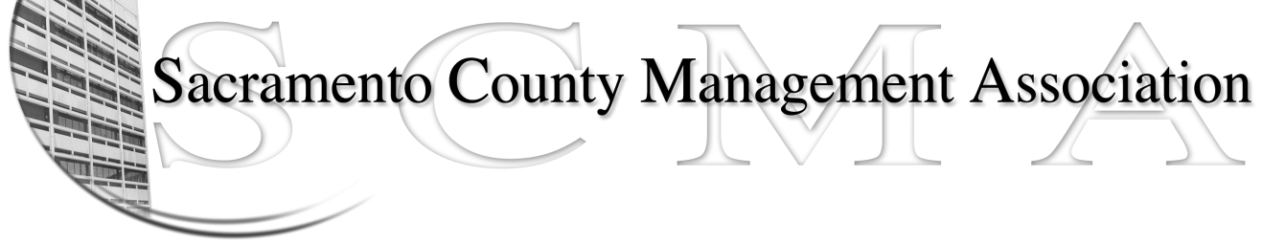

Kelsey Johnson, President Diana Ruiz, Vice-President
Jan Holm, Treasurer Nancy Gust, Secretary
Frances Worth, Board Member Darcy Moehring, Board Member
Pamela Harris, Board Member Cathy Girton, Board Member
Stephen Wallach, Board Member Kathy Bryan, Board Member
Bruce Coker, Board Member Vacant, Board Member

SCMA Board of Director’s Minutes
December 5, 2012 - 3:00 P.M.
9616 Micron Avenue, Suite 900

Attendance: Diana Ruiz, Darcy Moehring, Cathy Girton (proxy for Pamela Harris), Kathy Bryan (proxy for Frances Worth), Jan Holm, Kelsey Johnson, Bruce Coker, Stephen Wallach, Lynn Wynn (proxy for Nancy Gust)

Absent: Frances Worth, Pamela Harris, Nancy Gust

Guests: Sue Elliott, Mike Guiver, Matt Quinley, Lisa Scott-Lee

- Introductions

- Minutes: Motion: Accept November 7, 2012 Board of Directors Minutes by Diana and seconded by Kathy. Ayes – All

- Treasurer’s Report – Report provided

  - Audit Committee Update – Update provided. Two members had to step down from committee. Mike Guiver was appointed new chair of committee.

- Committee Reports
  - Association Meeting – report provided
  - Bylaws – Sue requested that any changes to bylaws be forwarded to her for consideration.
  - Elections – nothing to report
  - Website – nothing to report
  - Membership – 5 new non-paying members discovered that have been added to the database. Next meeting will review list for discussion on departmental liaisons.
  - Discipline – report provided
  - Meet & Confer – report provided

- Correspondence
  - Sacramento County Retired Employees Association Newsletter received

- Old Business
  - Board of Director Insurance Update – waiting for response from vendors

- New Business - none

- Adjourn 4:20 p.m.

- Closed Session

- Public Session – The Negotiating Committee will consist of the following:

Kelsey Johnson, SCMA President
Jan Holm, SCMA Treasurer
Rosemary Clark, SCMA Member
John Hinkley, SCMA Member

There is still one more member to be selected.

