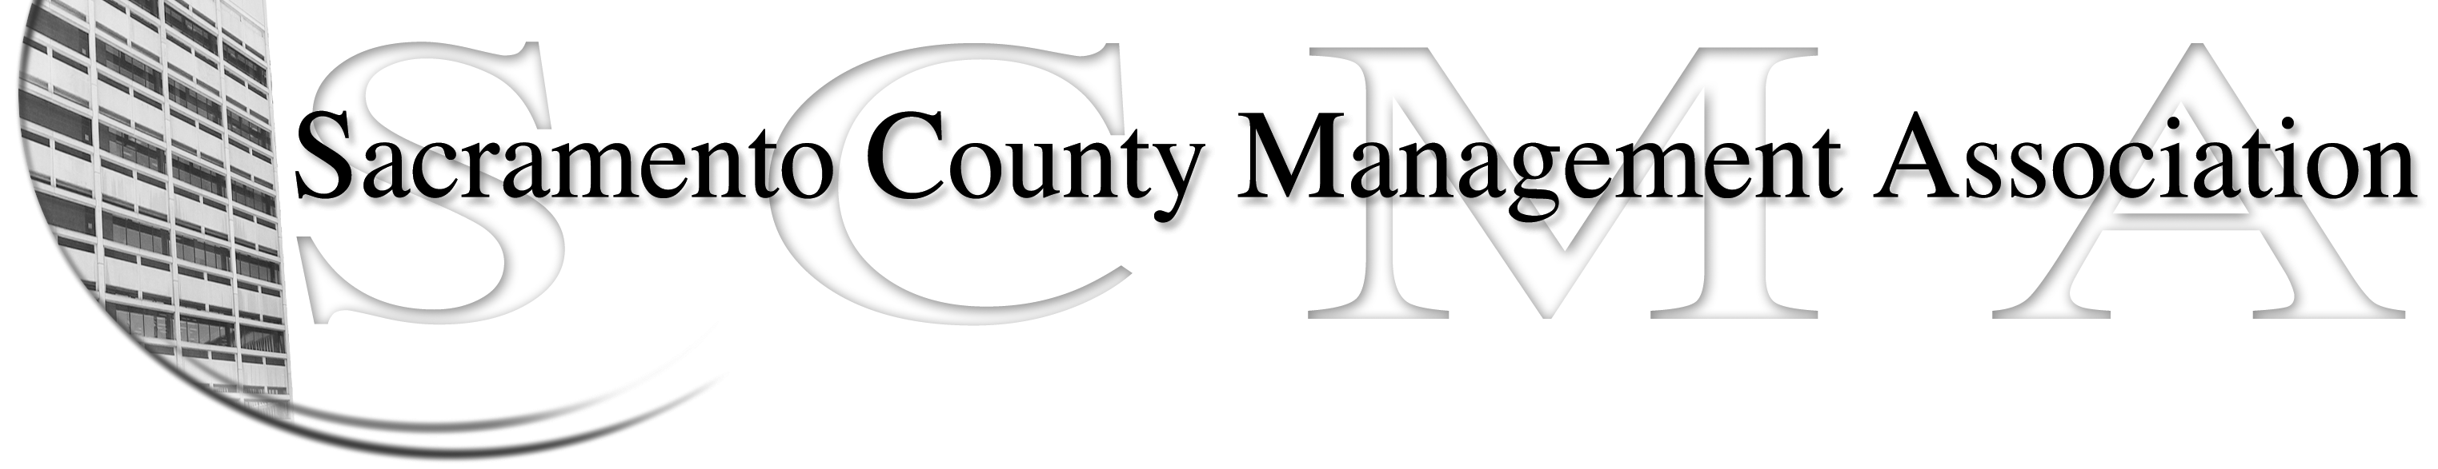

Mike Guiver, President Sue Elliott Board Member
RoseMary Vaske, Vice President Craig Rader, Board Member
Nancy Gust, Secretary Brad Buyse, Board Member
Forrest Williams, Treasurer Robert Nelson, Board Member
Kelsey Johnson, Board Member

SCMA Board of Director’s Agenda
December 1, 2010 – 12:30 P.M.
Voter Registration/SSD Florin Station - 7000 65th Street

- Review and approve the minutes from the November 3, 2010 Board of Director’s Meeting.

II. Treasurer’s Report - Forrest
  - Financial Report
  - Prior years’ tax return

III. Committee Reports
- Business Luncheon – Sue
- Bylaws / 2010 review –Sue
- Elections for 2010 – Lynn/Mike
- REO – RoseMary
- Website – Craig
- Membership recruitment - Nancy

- Correspondence

- Old Business
  - None

- New Business
  - Genworth Long-term Health Care follow-up - Lynn
  - How will grievances by handled by Board
  - Incoming/Outgoing Board Member January Lunch

VII. Adjournment

