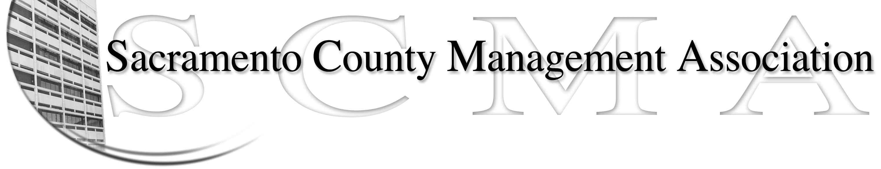

Kelsey Johnson, President Diana Ruiz, Vice President
Jan Holm, Treasurer Nancy Gust, Secretary
Frances Worth, Board Member Darcy Moehring, Board Member
Pamela Harris, Board Member Cathy Girton, Board Member
Stephen Wallach, Board Member Kathy Bryan, Board Member
Bruce Coker, Board member Vacant, Board Member

SCMA Board of Director’s Minutes
November 7, 2012 – 3:00 P.M.
9616 Micron Avenue, Suite 900

Attendance: Nancy Gust, Diana Ruiz, Frances Worth, Darcy Moehring, Cathy Girton, Pamela Harris, Kathy Bryan, Jan Holm, Kelsey Johnson

Absent: Stephen Wallach, Bruce Coker

Guests: John Hinkley, Kathleen Macias, Sharon di Pirro-Beard, Jason Jasmine

- Introductions

- Minutes: Motion: Accept October 3 Board of Directors Minutes by Jan and seconded by Darcy. Ayes – All

- Treasurers Report
  - Report was e-mailed to Board members and distributed at meeting.

- Committee Reports
  - Association – Jan – 138 attended – Food got so so reviews.

VII. New Business – Out of Order
Jason Jasmine gave an update of situation with County and the Board. Letter was received from the County regarding Board. Response letter was sent to Labor relations and nothing has been heard on the subject since.

IV. Committee Reports

  - Bylaws –Sue/Diana – No report

  - Elections – Kelsey – No report

  - Website – Craig – No report.

  - Membership – Darcy – 3 new members

  - Discipline – Lynn – Verbal Report

  - Meet & Confer – Diana - Report

- Correspondence

- Old Business - Cathy
  - Board of Directors Insurance Update
Cathy submitted application. $1 M insurance would cost $1,050 per year. There is a $1,000 deductible per occurrence and $2,500 deductible per employee per occurrence. Will try and get a second quote.

- New Business
  - Negotiation Team Makeup – Discussion on possible members of the team and the Chief Negotiator. Motion: To appoint Jason Jasmine as the Chief Negotiator for the next contract negotiations by Diana and seconded by Kathy. Ayes: All

- Adjourn 5:30 p.m.

- Closed Session

