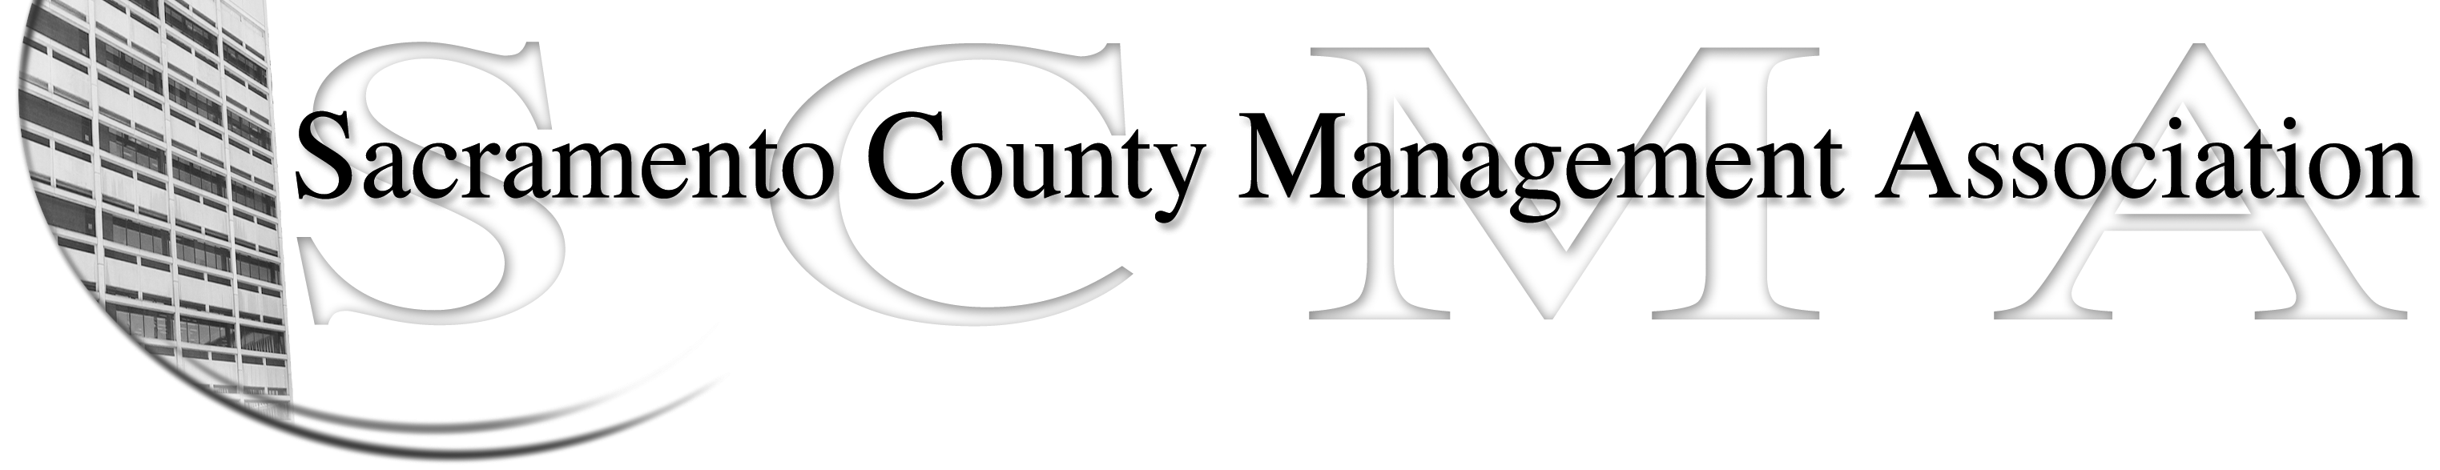

Mike Guiver, President Sue Elliott Board Member
RoseMary Vaske, Vice President Craig Rader, Board Member
Nancy Gust, Secretary Brad Buyse, Board Member
Forrest Williams, Treasurer Robert Nelson, Board Member
Kelsey Johnson, Board Member

SCMA Board of Director’s Agenda
November 3, 2010 – 12:30 – 2:30 P.M.
Granite Regional Center 3331 Power Inn Rd– Conference Room 1A

- Review and approve the minutes from the October 6, 2010 Board of Director’s Meeting.

II. Treasurer’s Report - Forrest
  - Financial Report
  - Prior years’ tax return

III. Committee Reports
- Business Luncheon – Sue
- Bylaws / 2010 review –Robert
- Elections for 2010 – Lynn/Mike
- REO – RoseMary
- Website – Craig
- Membership recruitment - Al

- Correspondence

- Old Business
  - None

- New Business
  - Genworth presentation on Long-term Health Care
  - Membership Recruitment – Department Contacts
  - How will grievances by handled by Board
  - Incoming/Outgoing Board Member January Lunch

VII. Adjournment

