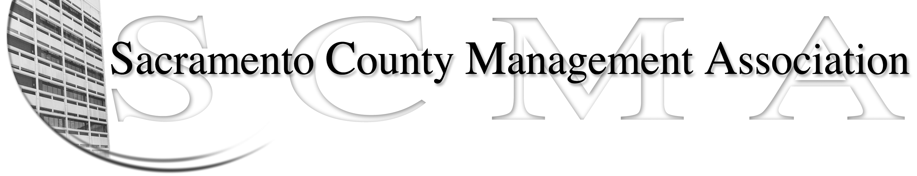

Kelsey Johnson, President Forrest Williams, Vice President
Nancy Gust, Secretary Jan Holm, Treasurer
Diana Ruiz, Board Member Darcy Moehring, Board Member Will Roman, Board Member Elizabeth Foster-Ward, Board Member Kathy Bryan, Board Member Cathy Girton, Board Member
Vacant, Board Member Vacant, Board Member

SCMA Board of Director’s Minutes
November 2, 2011 – 3:00 P.M.
Office Building 3 – 3701 Branch Center Road
Large Conference Room

Attendance: Kathy Bryan, Jan Holm, Elizabeth Foster-Ward, Diana Ruiz, Kelsey Johnson, Forrest Williams, Nancy Gust, Darcy Moehring

Absent: Cathy Girton, Will Roman

Guests: Sue Elliott, Lynn Wynn

- Introductions

- Minutes: Motion: Approve the October 5, 2011 Board of Director Minutes by Jan and seconded by Darcy. Ayes – All

- Treasurers Report
  - Handouts

- Committee Reports
  - Association – Jan/Will – Lunch reservations at 109

  - Bylaws – Sue/Diana – Changes will be brought back in December with final review in January

  - Elections – Kelsey – No report
IV. (Continued)

  - Website – Craig mailed out the website reports

  - Membership – Darcy – Recruiting materials all sent out by Darcy, Stephen and Nancy. E-mail was sent to current members about recruiting campaign and raffle prizes.

  - Discipline – Elizabeth – Motion: Sue will draft a letter to Labor Relations regarding the update on DHHS & DHHA Salary Compaction issues requested September 9, 2011 by Darcy and seconded by Jan. Ayes - All

  - Meet & Confer – Elizabeth – How do we document what is agreed to at Meet & Confers? The County provides a email or written memo documenting the meeting and any corrections.

- Old Business
  - Elections Process and Procedures – Nancy – Presented revisions to Process & Procedures revised by Brad & Nancy
  - Audit Committee – Randy Wolfe from Finance will be the third member of the committee. First meeting to be November 15, 2011.

- New Business
  - Brief discussion on how to proceed with Negotiations for 2013

VII. Adjourn 5:45 p.m.

