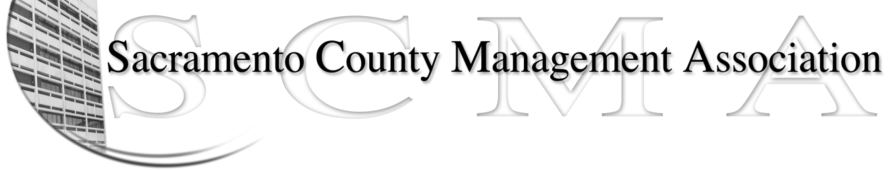

Kelsey Johnson, President Forrest Williams, Vice President
Nancy Gust, Secretary Jan Holm, Treasurer
Diana Ruiz, Board Member Darcy Moehring, Board Member Will Roman, Board Member Elizabeth Foster-Ward, Board Member Kathy Bryan, Board Member Cathy Girton, Board Member
Vacant, Board Member Vacant, Board Member

SCMA Board of Director’s Agenda
October 5, 2011 - 3:00 P.M.
Office Building 3 – 3701 Branch Center Road
Large Conference Room – 1st Floor

- Introductions

- Review and approve the minutes from the September 7, 2011 Board of Director’s Meeting

- Treasurer’s Report – Jan
  - Financial Report

- Committee Reports
  - Association Meeting – Jan/Will
  - Bylaws – Sue
  - Elections –
  - Website – Craig
  - Membership – Darcy
  - Discipline – Lynn
  - Meet & Confer – Elizabeth

- Correspondence

- Old Business

- New Business
  - Review of Elections Process and Procedures
  - Report from Audit Committee

- Adjournment

- Closed Session

