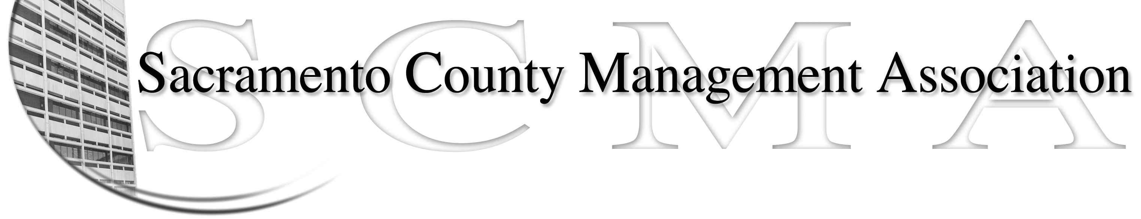

Kelsey Johnson, President Diana Ruiz, Vice President
Jan Holm, Treasurer Nancy Gust, Secretary
Frances Worth, Board Member Darcy Moehring, Board Member
Pamela Harris, Board Member Cathy Girton, Board Member
Stephen Wallach, Board Member Kathy Bryan, Board Member
Bruce Coker, Board member Vacant, Board Member

SCMA Board of Director’s Minutes
October 3, 2012 – 3:00 P.M.
9616 Micron Avenue, Suite 900

Attendance: Nancy Gust, Diana Ruiz, Kathy Bryan, Jan Holm, Kelsey Johnson, Darcy Moehring, Frances Worth, Jan (proxy for Pamela Harris)

Absent: Cathy Girton, Stephen Wallach

Guests: John Hinkley, Bruce Coker, Matt Quinley, Jesus Cervantes, Kathleen Macias, Lisa Scott-Lee

- Introductions

- Minutes: Motion: Accept September 5 Board of Directors Minutes by Diana and seconded by Kathy. Ayes – All

- Treasurers Report
  - Report was e-mailed to Board members and distributed at meeting.

- Committee Reports
  - Association – Jan – Presented tentative agenda and timeline for November lunch.

  - Bylaws –Sue/Diana – No report

  - Elections – Kelsey – No report

  - Website – Craig – No report.

  - Membership – Darcy – Update on number of members

  - Discipline – Kathy - Report

  - Meet & Confer – Diana - Report

- Correspondence

- Old Business - Cathy
  - No report

- New Business
  - Compaction Issue - Mental Health Program Coordinators – Representatives made a short presentation. Diana asked for more information and contact information.
  - AFSCME – is in negotiations

- Adjourn 4:43 p.m.

- Motion to appoint Bruce Coker to vacant Board of Directors seat by Diana and seconded by Kathy. Ayes - All Bruce was asked to come back in and attend the Closed Session.

- Closed Session

