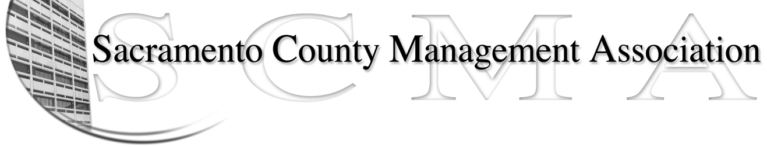

Kelsey Johnson, President Diana Ruiz, Vice-President
Jan Holm, Treasurer Forrest Williams, Board Member
Nancy Gust, Secretary Darcy Moehring, Board Member
Frances Worth, Board Member Cathy Girton, Board Member
Pamela Harris, Board Member Kathy Bryan, Board Member
Stephen Wallach, Board Member Vacant, Board Member

SCMA Board of Director’s Agenda
October 3, 2012 - 3:00 P.M.
9616 Micron Avenue, Suite 900 (Back of the complex)

- Introductions

- Review and approve the minutes from the September 5, 2012 Board of Director’s Meeting

- Treasurer’s Report – Jan

- Committee Reports
  - Association Meeting – Jan
  - Bylaws – Sue
  - Elections – Kelsey/Roberta
  - Website – Craig
  - Membership – Darcy
  - Discipline – Lynn -
  - Meet & Confer – Diana
- Correspondence

- Old Business
  - LTD – Board of Director Ins Updates

- New Business
  - Discussion of next negotiations – team make-up, etc.

- Adjournment

- Closed Session

