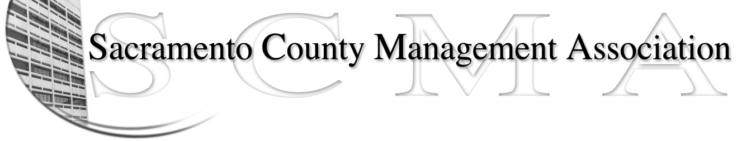

Kelsey Johnson, President Diana Ruiz, Vice President
Jan Holm, Secretary Craig Rader, Board Member
Stephen Wallach, Treasurer Darcy Moehring, Board Member
Pamela Harris, Board Member Rey Rodriguez, Board Member
Vacant, Board Member Kathy Bryan, Board Member
Vacant, Board Member Joseph Sellner, Board Member
(terms ending 06/2014) (terms ending 06/2015)

SCMA Board of Director’s Agenda
October 2, 2013 - 3:00 P.M.
9616 Micron Avenue, Suite 900 (Back of the complex)

- Introductions

- Review and approve the minutes from the September 4, 2013 Board of Director’s Meetings

- Treasurer’s Report – Jan/Stephen

- Committee Reports
  - Association Meeting –Stephen
  - Bylaws – Sue
  - Elections –Michelle Espy
  - Website – Craig
  - Membership – Darcy
  - Discipline – Kathy
  - Meet & Confer – Diana

- Correspondence

- Old Business
  - Board of Director Ins Recommendation-Michelle Espy
  - CSEA Membership Update – Jan

- New Business

- Adjournment

- Closed Session

