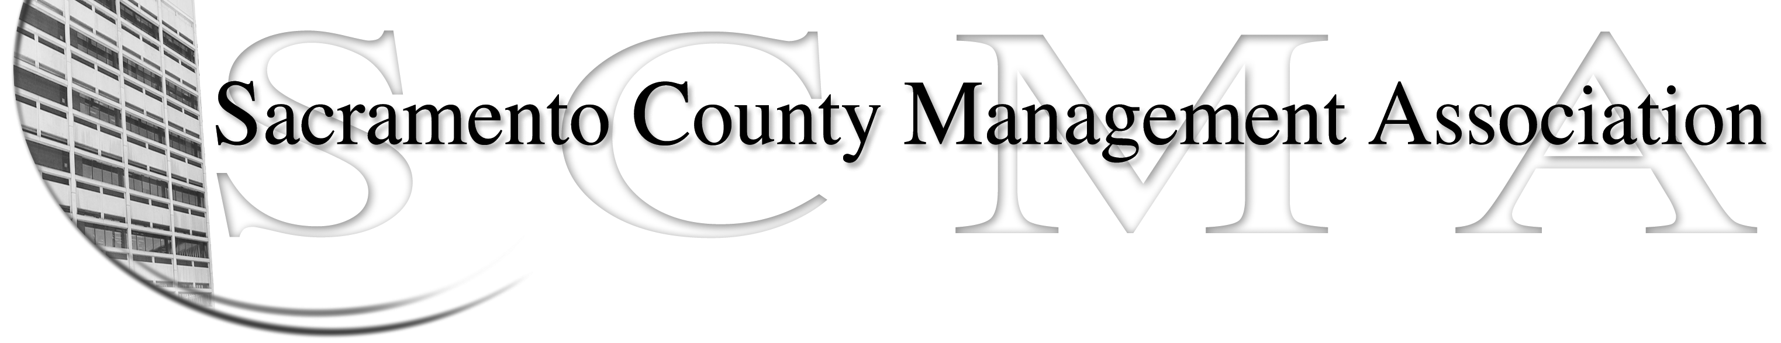
Mike Guiver, President Sue Elliott, Board Member
Rosemary Vaske, Vice President Craig Rader, Board Member
Nancy Gust, Secretary Brad Buyse, Board Member
Forrest Williams, Treasurer Robert Nelson, Board Member
Kelsey Johnson, Board Member

SCMA Special Meeting Minutes
September 9, 2010, 1 P.M.
Voter Registration, 65th Street

Attendance: Mike Guiver, Rosemary Vaske, Forrest Williams, Kelsey Johnson, Sue Elliott, Brad Buyse, Robert Nelson.

Absent: Nancy Gust, Craig Rader

Guests: Lynn Wynn

The purpose of the special meeting was to continue the work on proposed revisions and updates in order to complete a revised draft of the SCMA bylaws. The draft was reviewed line by line with specific notes of changes being recorded by Robert and Lynn.

Section V of draft, Board of Directors, l and m – RoseMary will ask Jason if there is a need to have language to address the fiduciary responsibility of the Board. Note of 09/15/10: Mr. Jasmine has informed the president and vice president that language regarding fiduciary responsibilities is not necessary to include in the bylaws as it is detailed in the government code.

Robert resigned as the chairperson of the Bylaws Committee.

Sue made a motion to accept the proposed changes through Section V of the draft bylaws and to allow the Board to vote on proposed changes for the remainder of the bylaws draft using either email or survey monkey. Forrest seconded the motion. Ayes – All.

There was discussion about Section XII and XIII of the draft bylaws. There may not be a need to include these sections in the bylaws as these sections may be addressed in the Collective Bargaining Agreement. Due to the late hour the meeting ended. Lynn is going to continue working on the draft of the bylaws.

The meeting adjourned at 4 P.M.

