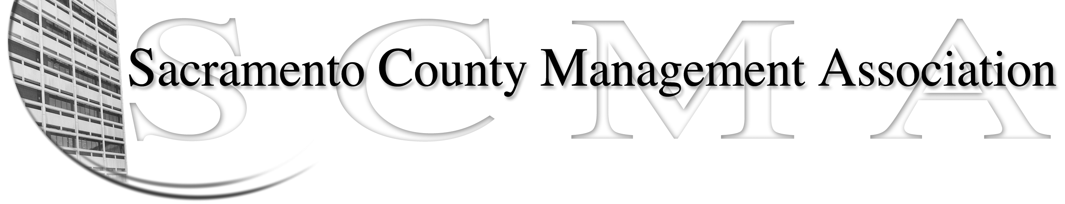

Kelsey Johnson, President Forrest Williams, Vice President
Nancy Gust, Secretary Jan Holm, Treasurer
Diana Ruiz, Board Member Darcy Moehring, Board Member Will Roman, Board Member Elizabeth Foster-Ward, Board Member Kathy Bryan, Board Member Cathy Girton, Board Member
Vacant, Board Member Vacant, Board Member

SCMA Board of Director’s Minutes
September 7, 2011 – 3:00 P.M.
Office Building 3 – 3701 Branch Center Road
Large Conference Room

Attendance: Kathy Bryan, Jan Holm, Elizabeth Foster-Ward, Diana Ruiz, Darcy Moehring, Kelsey Johnson, Forrest Williams, Will Roman, Nancy Gust

Absent: Cathy Girton

Guests: Cindy Sawhill, Lynn Wynn

- Introductions
- Minutes: Motion: Approve August 3, 2011 Board of Director Minutes by Jan and seconded by Elizabeth. Ayes – 6; Abstentions – 1
- Treasurers Report
  - Extension of time received to file 2010 tax returns which are completed on a fiscal year basis. They are now due November 15, 2011.
  - Audit Committee will be meeting soon.
  - Current balance as of August is $45,113
  - SCMA budget needs to be compiled for distribution at business lunch
- Committee Reports
  - Association – Jan/Will – Will is helping Jan with the business lunch. Kelsey asked the new County Executive Bradley Hudson to be the Keynote Speaker but has not heard back yet
  - Bylaws – Lynn – Collect all edits of By-Laws for Sue. Still need members to review.
  - Elections – Kelsey – Still need new chair
  - Website – Craig mailed out the website reports
  - Membership – Darcy – Prepared a proposal for a Membership Recruitment Drive. Motion: Approve concept of Membership Recruitment Drive with no deferral of dues with Darcy as Chair. Ayes – All
  - Discipline – Lynn – Lynn, Cindy, Kelsey, Elizabeth, Kathy Bryan will be receiving mediation training from Jason
  - Meet & Confer – Elizabeth – Probation and CMO continuing
- Old Business
  - CMO – Met with Nottoli, Peters and Yee regarding issue. Kelsey spoke at Board Hearing and distributed a letter to all Supervisors and Mr. Hudson. Meet & Confer to take place soon.
  - Sue wanted to know where the Nurse Compaction letter was in the process.
- New Business
  - Review of Election Process & Procedures – Deferred
  - Special Committees – Election Chair to be determined
  - Report from Audit Committee– In progress
  - Business Lunch Agenda – Reports for: Financial, Discipline, Grievance, Meet & Confer, Plaques for outgoing board members, Introductions, Keynote Speaker. Nancy to check old minutes to see if backup Keynote Speaker was suggested.
VII. Adjourn 5:12 p.m.

