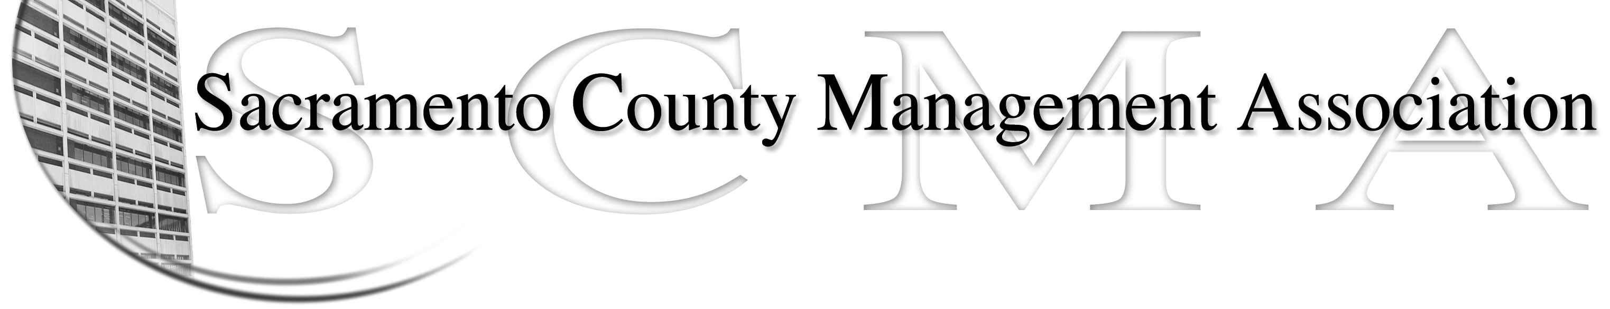

Kelsey Johnson, President Diana Ruiz, Vice President
Jan Holm, Treasurer Forrest Williams, Board Member
Nancy Gust, Secretary Darcy Moehring, Board Member
Frances Worth, Board Member Cathy Girton, Board Member
Pamela Harris, Board Member Kathy Bryan, Board Member
Stephen Wallach, Board member Vacant, Board Member

SCMA Board of Director’s Minutes
September 5, 2012 – 3:00 P.M.
9616 Micron Avenue, Suite 900

Attendance: Nancy Gust, Kelsey Johnson, Kathy Bryan, Lynn Wynn (proxy for Forrest), Diana Ruiz, Jan Holm, Darcy Moehring, Pamela Harris, Cathy Girton, Frances Worth, Stephen Wallach

Absent:

Guests: Craig Rader, Bruce Coker, Elizabeth Weeks, Sue Elliott, Mary Bishop

- Introductions

- Minutes: Motion: Approve August 1, 2012 Board of Director Minutes by Lynn and seconded by Diana. Ayes – All

VII. New Business (Out of Order)
  - Speaker from Sacramento Law Enforcement Chaplaincy regarding an event on November 7, 2012 looking for sponsorship.

- Treasurers Report
  - Handouts Distributed

- Committee Reports
  - Association – Jan – Luncheon will be November 1st at the Hilton. No speaker. Jan will prepare agenda, contact CBM for a donation and get movie tickets. Craig will draft luncheon notice.

  - Bylaws –Sue/Diana – No report

  - Elections – Kelsey – No report

  - Website – Craig – E-mailed to Board members.

  - Membership – Darcy – Has recruited several new members by phone calls. She will e-mail board members the “Point of Discussion” she has been using.

  - Discipline – Lynn - Report

  - Meet & Confer – Diana – Closed Session

- Correspondence

- Old Business - Cathy
  - Cathy is filling out the questionnaire for the Board of Directors insurance. Will have an updated at the next meeting

- New Business
  - Audit Committee – Kelsey appoints Andy Hong Lun Ya as Committee Chair.
  - Continue Law Enforcement Chaplaincy item. Motion: To not donate or post info of website about event made by Kelsey and seconded by Diana. Ayes – All
  - Donation Policy – Motion to make it a policy to not donate to any charity or post any information by Diana and seconded by Cathy. Ayes - All

- Adjourn 5:04 p.m.

- Closed Session

