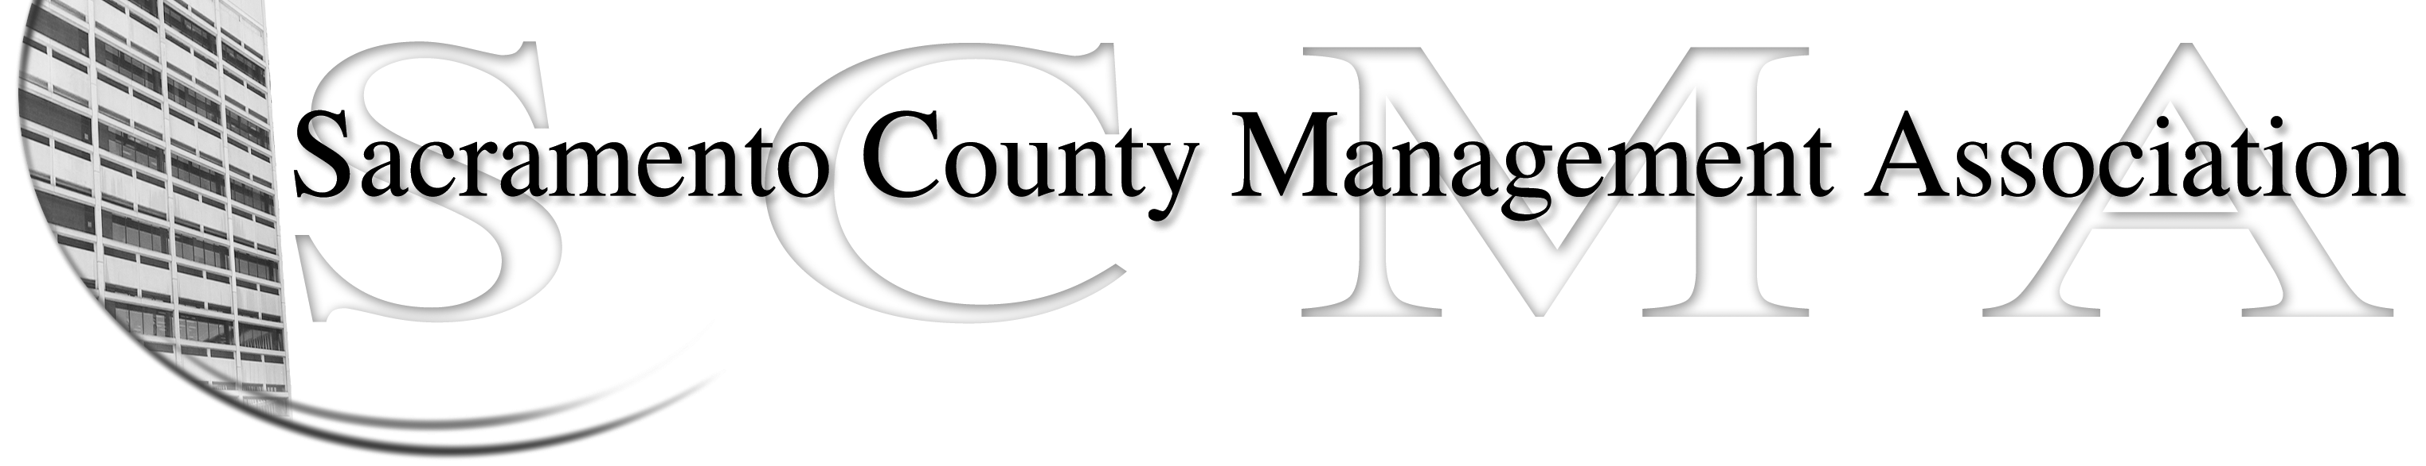

Phil Fiscbach, President |  | Nancy Gust, Board Member
Sue Elliott, Vice President |  | Mike Guiver, Board Member
RoseMary Vaske, Secretary |  | Robert Nelson, Board Member
Forrest Williams, Treasurer |  | Craig Rader, Board Member
Al Mateer, Past President |  | Brad Buyse, Board Member
 |  | Vacant

SCMA Board of Director’s Special Meeting

Minutes from Meeting

12 Noon – August 6, 2009

Voter registration conference Room – 65th Street

In attendance: Sue Elliott, Brad Buyse, Al Mateer, Mike Guiver, Craig Rader, Robert Nelson, Nancy Gust, RoseMary Vaske

Absent: Phil Fischbach, Forrest Williams

Guests: Roberta Kenelos, Alice Jarboe, Frank Fregoso, Lynn Wynn.

The special meeting was held to discuss two items: preparing our presentations for the August 11th BOS Meeting and to debrief from the informational meeting with the attorneys from Carroll, Burdick and McDonough and Rebecca Rhine, SFMEA.

- Preparing for the August 11th Board of Supervisors Meeting: We are preparing to address the BOS on the issue of the management sick leave retirement cash out benefit. Nav spoke to Brad and RoseMary on the phone indicating that he and Terry were going to request that the BOS remove this item from their “report back” agenda. We have had no official notification that this is the Board’s plan and to date the meeting agenda has not been available for review. We believe that it is important that we bring this concern as well as several other concerns to the attention of the BOS. Our plan is that there will be at minimum of 5 speakers from SCMA. 1. Phil to make opening comments and present the list of all 050 members to the BOS, 2. Al will address the sick leave cash out benefit, 3. Mike (or RoseMary) will present information on the REO concessions chart, 4. Robert will present the results of the 050 petition, and Lynn will speak to the salary compaction issues. Nav will also be reminded that he has not provided the answers to the questions present to him at the SCMA Spring luncheon as promised. The questions are posted on the SCMA website. Note; Nav was sent an email reminder of this oversight earlier this week.

SCMA sent out an email blast to members who have provided their email addresses requesting their presence at the meeting on August 11th. Another email blast will be sent out on Sunday, August 9th.

- Debrief from the information meeting with the attorneys from Carroll, Burdick and McDonough and Rebecca Rhine, SFMEA: There was consensus that it was a helpful meeting and allowed for some fears to be put aside. The meeting reinforced the important that management needs to be a part of the solution and recognized for their collective experience and skill. There was interest in looking at affiliation with the SFMEA rather than starting a free standing and separate organization and rather than joining with a national union. Following a lengthy discussion it was determined that we needed to contact the attorneys and Rebecca to ask about the specific next steps and clarification on who can and cannot be a member. RoseMary will contact the attorneys and Rebecca to obtain this information prior to the August 18th meeting.

A motion was made by Al and seconded by Nancy to adjourn the meeting at 2:10 P.M.

