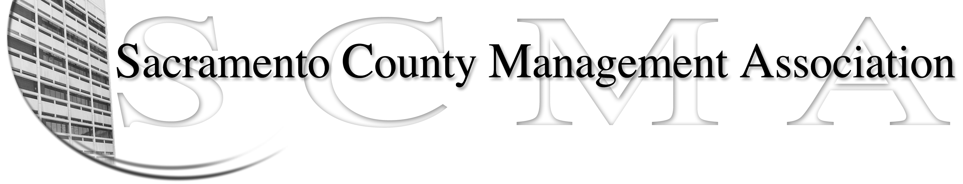

Mike Guiver, President Sue Elliott Board Member
RoseMary Vaske, Vice President Craig Rader, Board Member
Nancy Gust, Secretary Brad Buyse, Board Member
Forrest Williams, Treasurer Robert Nelson, Board Member
Michelle Espy, Board Member

SCMA Board of Director’s Agenda
August 4, 2010 – 12:30 – 1:30 P.M. Open Session
1:30 – 3:30 P.M. Closed Session
Voter Registration – 7000 65th Street – Sheriff Side

- Review and approve the minutes from the June 24 General Membership Meeting and July 7, 2010 Board of Director’s Meetings..

II. Treasurer’s Report - Forrest
  - Financial Report
  - Prior years’ tax return

III. Committee Reports
- Business Luncheon – Sue
- Bylaws / 2010 review –Robert
- Elections for 2010 – Robert
- REO – RoseMary
- Website – Craig
- Membership recruitment - Al

- Correspondence

- Old Business

- New Business
  - New Classifications

VII. Closed Session
a. Board member training

VIII. Adjournment

