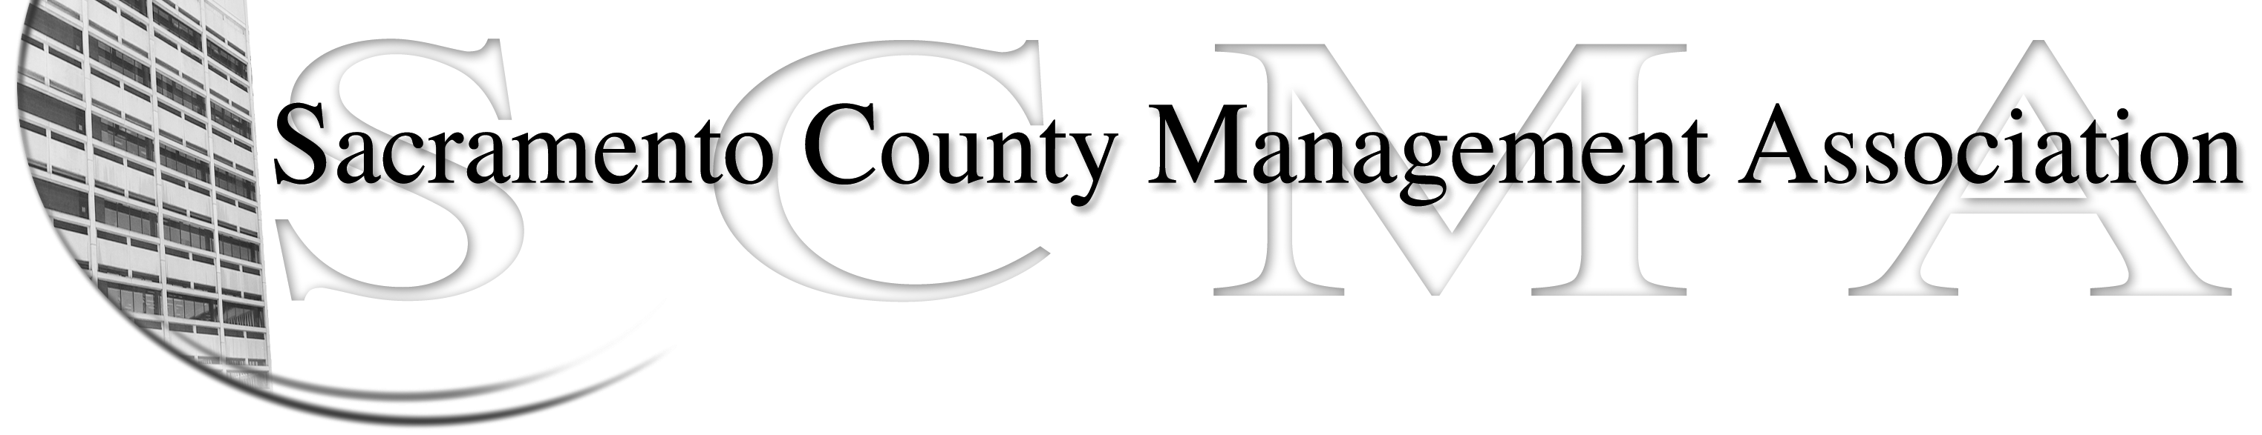

Kelsey Johnson, President Forrest Williams, Vice President
Nancy Gust, Secretary Jan Holm, Treasurer
Diana Ruiz, Board Member Brad Buyse, Board Member
Will Roman, Board Member Elizabeth Foster-Ward, Board Member
Kathy Bryan, Board Member Cathy Girton, Board Member
Darcy Moehring, Board Member Vacant, Board Member

SCMA Board of Director’s Minutes
August 3, 2011 – 3:00 P.M.
Office Building 3 – 3701 Branch Center Road
Large Conference Room

Attendance: Kelsey Johnson, Jan Holm, Darcy Moehring, Will Roman, Diana Ruiz, Cathy Girton, Elizabeth Foster-Ward, Nancy Gust

Absent: Kathy Bryan, Forrest Williams, Brad Buyse

Guests: Craig Rader, John Hinkley, Mike Guiver, Dan Regan

- Introductions
- Minutes – Motion: Approve July 6, 2011 Board of Director’s Minutes as corrected by Kelsey and seconded by Cathy. Ayes – 6 (New location and groups were in two different rooms. Minutes were approved with quorum before the two groups combined)
- Treasurer’s Report –Jan – No report
  - Audit Committee – Motion: Appoint Monica Voetsch, George McElroy and Jeff King as members of the Audit Committee made by Kelsey and seconded by Elizabeth. Ayes – All – Jan will coordinate
  - Received Sacramento Credit Union statement, June invoice from CBM and statement on prior invoices from CBM.
- Committee Reports
  - Association Meeting – No report
  - By-Laws – Nancy – Distributed copies of By-Laws prepared by Sue for review and mark-up Diana Ruiz is on committee but still looking for more members.
  - Elections – Kelsey
    - Brad has submitted his resignation from the Board of Directors and as Committee Chair.
  - Website – Craig – emailed reports to board members
  - Membership – Nancy – No activity for July
  - Discipline – Nancy – Distributed report prepared by Lynn Wynn
  - Meet & Confer
    - CMO – Dan Regan spoke about a meeting that occurred. Kelsey and Elizabeth attended session over CMO issues. Further discussion to take place.
    - County Clerk Recorder – Elizabeth / Diana - – Met with Craig Kramer over possible position changes. SCMA to review MQ’s for Asst. County Clerk/Recorder
- Correspondence
- Old Business – None
- New Business
  - Review of Elections Process and Procedure – Continued
  - Special Committees – Kelsey appointed the following:
    - Membership – Darcy Moehring
    - Association Meeting – Jan willing to give up
    - By – Law -Sue Elliott – Diana Ruiz member
    - Meet & Confer – Elizabeth Foster-Ward, Diana Ruiz, Forrest Williams
    - Website – Craig Rader
    - Discipline – Lynn Wynn, Elizabeth Foster-Ward, Cindy Sawhill
    - Compaction – Sue Elliott, Jan Holm, Bernice Walton, Mike Guiver
    - Insurance Review (LTD, Director/Member Liability) – Cathy Girton
  - Compaction issue – Nancy – Presented letter prepared by Sue Elliott over issue at DHA with Chief Criminal Investigator. Motion: To have Kelsey sign the letter and send to Labor Relations made by Diana and seconded by Elizabeth. Ayes – 6
- Adjournment 5:28 p.m.
- Closed Session

