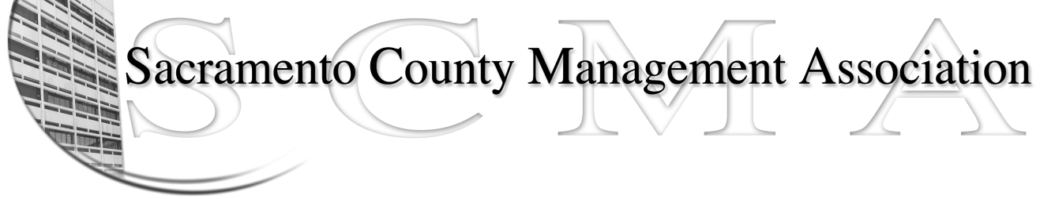

Kelsey Johnson, President Diana Ruiz, Vice-President
Jan Holm, Treasurer Forrest Williams, Board Member
Nancy Gust, Secretary Darcy Moehring, Board Member
Frances Worth, Board Member Cathy Girton, Board Member
Pamela Harris, Board Member Kathy Bryan, Board Member
Stephen Wallach, Board Member Vacant, Board Member

SCMA Board of Director’s Agenda
August 1, 2012 - 3:00 P.M.
NEW LOCATION *** 9616 Micron Avenue, Suite 900

- Introductions

- Review and approve the minutes from the July 11, 2012 Board of Director’s Meeting

- Treasurer’s Report – Jan

- Committee Reports
  - Association Meeting – Jan
  - Bylaws – Sue
  - Elections – Kelsey/Roberta
  - Website – Craig
  - Membership – Darcy
  - Discipline – Lynn
  - Meet & Confer

- Correspondence

- Old Business
  - LTD – Board of Director Ins Updates

- New Business
  - SCMA Meeting Date, Time and Location
  - Appointment of new Meet & Confer Chair person

- Adjournment

- Closed Session

