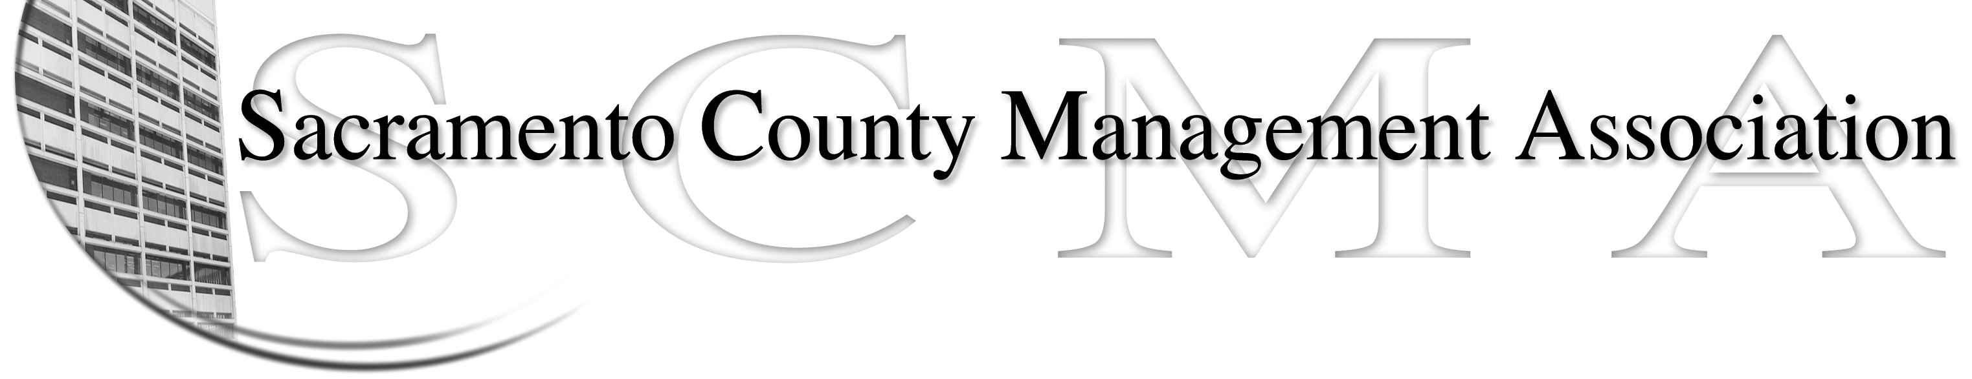

Kelsey Johnson, President Diana Ruiz, Vice President
Jan Holm, Treasurer Forrest Williams, Board Member
Nancy Gust, Secretary Darcy Moehring, Board Member
Frances Worth, Board Member Cathy Girton, Board Member
Pamela Harris, Board Member Kathy Bryan, Board Member
Stephen Wallach, Board member Vacant, Board Member

SCMA Board of Director’s Minutes
July 11, 2012 – 3:00 P.M.
Office Building 3 – 3701 Branch Center Road
1st Floor Conference Room

Attendance: Jan Holm, Kelsey Johnson, Diana Ruiz, , Jan Holm (proxy for Darcy Moehring), Kathy Bryan, Lynn Wynn (proxy for Frances Worth), Stephen Wallach (3:30 pm)

Absent: Forrest Williams, Pamela Harris, Frances Worth, Darcy Moehring, Cathy Girton

Guests: John Hinkley

- Introductions

VII New Business – Out of Order
a. Appointment of vacant positions – Motion to appoint Nancy Gust to fill the vacant Fiscal Year 11/12 -12/13 board seat. Ayes - All
b. Election of Officers
1. Nomination & acceptance of Kelsey Johnson for President. Motion to elect Kelsey Johnson to the position of President by Jan and seconded by Kathy. Ayes – All
2. Nomination & acceptance of Diana Ruiz for position of Vice-President. Motion to elect Diana Ruiz to position of Vice-President by Kelsey and seconded by Jan. Ayes – All
3. Nomination & acceptance of Jan Holm for position of Treasurer. Motion to elect Jan Holm to the position of Treasurer by Lynn and seconded by Kathy. Ayes - All
4. Nomination & acceptance of Nancy Gust for position of Secretary. Motion to elect Nancy Gust to position of Secretary by Diana and seconded by Lynn. Ayes – All

- Minutes: Motion: Approve June 6, 2012 Board of Director Minutes as corrected by Jan and seconded by Lynn. Ayes – 6, Abstain - 1

- Treasurers Report
  - Handouts – E-mailed to board members
  - Jan Holm will contact the Jeff King to ask if he would be willing to serve as Chair of the Audit Committee. Jeff will select his other two committee members. Kelsey appointed Jan to serve as the liaison between the committee and the Board.

- Committee Reports
  - Association – Jan – No report

  - Bylaws –Sue/Diana – No report

  - Elections – Kelsey – No report

  - Website – Craig – E-mailed to Board members.

  - Membership – Darcy – No report

  - Discipline – Lynn - Report

  - Meet & Confer – Diana
    - Nurse Compaction –Still needs Chair that is involved in process
    - Is IT class study occurring? Diana will check
    - SCERS is looking at Retirement Services Specialist unit designation
    - DCSS has proposed a dress code
    - Joint Labor-Management meeting will be July 17, 2012
    - Class studies for Highway Maintenance Manager and Telecomm positions

- Correspondence

- Old Business
  - Cathy – No report
  - LTD – Nancy will complete voluntary deduction forms to bring all current LTD members back to dues only amount.

- New Business
c. SCMA Meeting Date, Time Location – Keep the 1st Wednesday of each month at 3:00 p.m. at OB3.

- Adjourn 4:40 p.m.

- Closed Session

