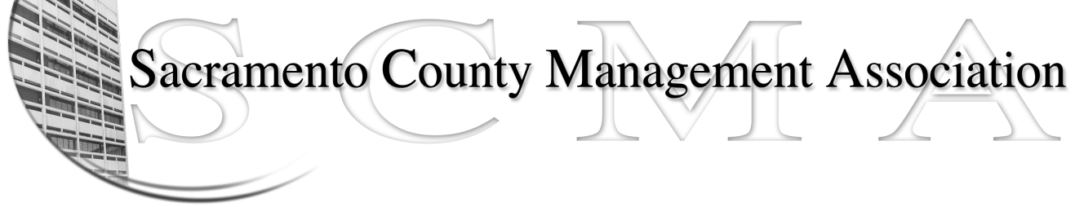

Kelsey Johnson, Acting President Forrest Williams, Acting Vice-President
Vacant, Secretary Jan Holm, Acting Treasurer
Diana Ruiz, Board Member Darcy Moehring, Board Member Stephen Wallach, Board Member Vacant, Board Member
Kathy Bryan, Board Member Cathy Girton, Board Member
Frances Worth, Board Member Pamela Harris, Board Member

SCMA Board of Director’s Agenda
July 11, 2012 - 3:00 P.M.
Office Building 3 – 3701 Branch Center Road
1st Floor Large Conference Room

- Introductions

- Review and approve the minutes from the June 6, 2012 Board of Director’s Meeting

- Treasurer’s Report – Jan
  - Financial Report

- Committee Reports
  - Association Meeting – Jan
  - Bylaws – Sue
  - Elections – Kelsey/Roberta
  - Website – Craig
  - Membership – Darcy
  - Discipline – Lynn
  - Meet & Confer

- Correspondence

- Old Business
  - LTD – Board of Director Ins Updates

- New Business
  - Appointment of vacant positions
  - Election of Officers
  - SCMA Meeting Date, Time and Location
  - Appointment of new Meet & Confer Chair person

- Adjournment

- Closed Session

