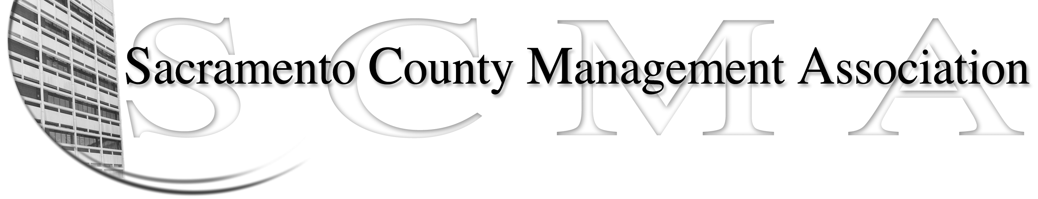

Kelsey Johnson, President Forrest Williams, Vice President
Nancy Gust, Secretary Jan Holm, Treasurer
Diana Ruiz, Board Member Brad Buyse, Board Member Will Roman, Board Member Elizabeth Foster-Ward, Board Member Kathy Bryan, Board Member Cathy Girton, Board Member
Darcy Moehring, Board Member Vacant, Board Member

SCMA Board of Director’s Minutes
July 6, 2011 – 3:00 P.M.
Sheriff’s Rockingham Station – 10361 Rockingham

Attendance: Kelsey Johnson, Brad Buyse, Jan Holm, Darcy Moehring, Will Roman, Sarah Britton (proxy for Diana Ruiz), Kathy Bryan, Cathy Girton, Forrest Williams, Nancy Gust (Lynn Wynn proxy for Nancy)

Absent: Elizabeth Foster-Ward

Guests: Craig Rader, Piper Wilson, John Hinkley, Lynn Wynn, Mike Guiver, Sue Elliott, Dan Regan

- Introductions

- Minutes – Motion: Approve June 1, 2011 Board of Director’s Minutes as corrected by Darcy and seconded by Brad. Ayes – Unanimous

- Treasurer’s Report – Handout

- Committee Reports
  - Association Meeting – Jan – 41 have RSVP’d for lunch. Motion: Invite the new CEO to be the keynote speaker at the November lunch meeting, made by Kelsey and seconded by Jan. Ayes - Unanimous
  - By-Laws – Sue – Sue will bring copies for next meeting
  - Elections – Brad – Election committee working on election procedures. Copy presented to Board members for comments due July 20, 2011. The committee will work with Sue on any necessary changes to the By-Laws.
  - Website – Craig – Stats were emailed to board members
  - Membership – Nancy – Five new members for June. Email copy of member/non-member list to Board members
.
  - Discipline – Lynn – There are two potential grievances being reviewed, two new discipline matters and results are pending from a Skelly hearing

  - Meet & Confer – Kelsey
    - Sanitation – Decision on new position was that it would belong to 050 not 032 after reviewing the MQ’s and job duties
    - Proposed salary was 5% spread above subordinate classes
    - CMO – Meet & confer was dropped because of actions taken at the June budget hearings. There are other issues so one may be requested.
    - Probation – May have issues to discuss in Meet & Confer

- Correspondence
  - CBM May Invoice
  - Credit union statement

- Old Business – None

- New Business
  - Selection of new officers
    - President – Kelsey was nominated and accepted. Motion: Elect Kelsey Johnson to serve as President by Forrest, seconded by Brad. Ayes – Unanimous
    - Vice President – Forrest was nominated and accepted. Motion: Elect Forrest Williams as Vice President by Brad and seconded by Sarah. Ayes - Unanimous
    - Treasurer - Jan was nominated for Treasurer and accepted. Motion: Elect Jan Holm as Treasurer by Nancy and seconded by Kathy. Ayes – Unanimous
    - Secretary – Nancy was nominated and accepted. Motion: Elect Nancy Gust as Secretary by Lynn and seconded by Brad. Ayes – Unanimous
    - Craig to draft and send email on officer selection with a reminder to sign up for the November lunch
  - Selection of meeting date, time and location
    - Discussion was held on the above. Motion: To hold the future board meetings the 1st Wednesday of each month at 3:00 p.m. at the Sanitation District Main Office – 10060 Goethe Road for the next six months pending availability by Kelsey and seconded by Sarah. Ayes – Unanimous
  - CEO positions
    - CMO positions – Positions for Water and Transportation were saved but they want to put everyone into a pool to complete the work. This is an issue with funded/non-funded and seniority. Kelsey and Forrest will contact Labor Relations to set up meet & confer to address issues.
  - Board Training –
    - There was discussion on having Jason Jasmine provide training on board responsibilities, grievances and discipline. Kelsey will follow up with Jason to see if he has training materials he did for other counties we can look at. Board members asked to think about what types of training we might need from Jason and provide suggestions to Kelsey. Motion: Pre-authorization to discipline committee for up to 3 hours of training if needed by Kelsey, seconded by Brad. Ayes – Unanimous
  - Chief Investigator and Asst. Chief Investigator Compaction Issues
    - Sue brought this issue to the table that is occurring in the Dept. of Human Assistance. Motion: Authorization for Sue to talk to Director Paul Lake to resolve compaction issue and to report back to Board of Directors on how to proceed made by Kelsey and seconded by Darcy. Votes: Unanimous

- Adjournment – 5:30 p.m.

- Closed Session

