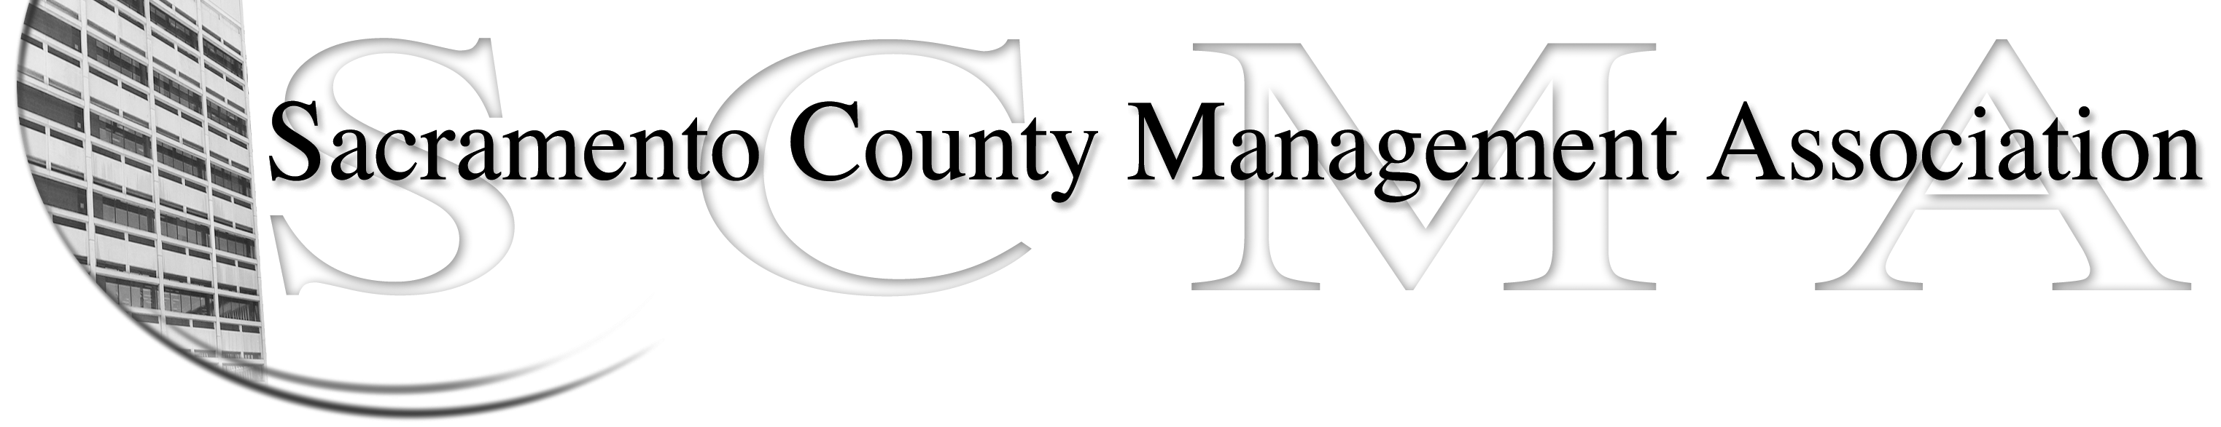

Mike Guiver, President Sue Elliott Board Member
RoseMary Vaske, Vice President Craig Rader, Board Member
Nancy Gust, Secretary Brad Buyse, Board Member
Forrest Williams, Treasurer Robert Nelson, Board Member
Bruce Coker, Board Member

SCMA Special Meeting Agenda
12:00 P.M. – June 15, 2010
Sheriff’s Department – 711 G Street – 3rd Floor Conference Room

I. Selection of Chief Negotiator

- Vacant Board Positions

III. REO

