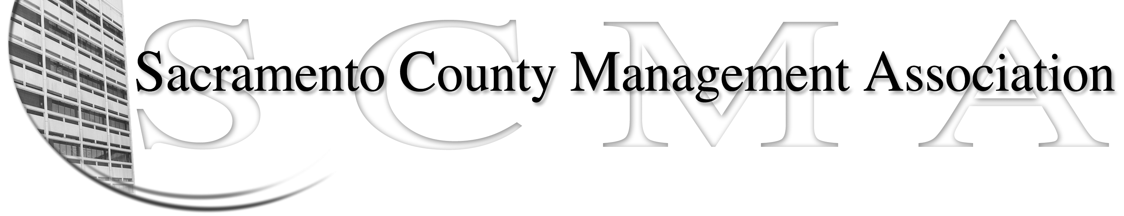

Phil Fiscbach, President |  | Nancy Gust, Board Member
Sue Elliott, Vice President |  | Mike Guiver, Board Member
RoseMary Vaske, Secretary |  | Robert Nelson, Board Member
Forrest Williams, Treasurer |  | Craig Rader, Board Member
Al Mateer, Past President |  | Brad Buyse, Board Member
 |  | Vacant

SCMA Board of Director’s Minutes

9 A.M., June 9, 2009

Architectural Services Division Offices, Mather, CA 95655

In Attendance: Phil Fischbach, Nancy Gust, Robert Nelson, Craig Rader, RoseMary Vaske, Mike Guiver, Brad Buyse

Absent: Forrest Williams, Sue Elliott, Al Mateer

Guests: Lynn Wynn, Amelia Schendal, Robert Stovall, and Warren Wiekel

- Review and approval of minutes of the Board meeting of 05/12/09. Nancy moved to approve the minutes of the May 12, 2009 meeting. Mike seconded. AYES – all, NAYS – none, ABSTENTIONS – none. The minutes were approved as written.
- Treasurer’s Report – There was no Treasurer’s report. The members noted that the webmaster has not been paid for two months. There are outstanding expenses related to the past luncheons for movie tickets and copying expenses. Members were asked to submit receipts for expenses to the Treasurer so these issues can be resolved. Phil will call and talk with Forrest.
- Committee Report
  - Website update – Discussion took place regarding the need to maintain the relationship with the webmaster vs. a board member taking on this responsibility. Following discussion it was decided to continue the relationship with the webmaster as the quality, cost and timeliness of the work performed is very good.
  - Spring luncheon – Sue was not present at the meeting to provide a final report but all members expressed their opinion that the luncheon was very successful and that the venue was much better than the Dante Club. Phil thanked everyone for their help in making the luncheon so successful with special recognition of Sue and Craig’s efforts. The fall business luncheon on Oct. 29th will also be at the Hilton. We will plan on using the Hilton’s sound system at the next luncheon.
- Correspondence – No correspondence was received.
- Old Business
  - Progress update on the Benefits (RFP) survey – Phil reported that the RFP was mailed to three firms. A panel was established to review the responses to the RFP. Craig will chair the panel. Additional panel members are Mike, Phil and Nancy. This item will be on the July agenda for discussion
  - Review of proposed bylaws changes – The completion of the review was deferred. The committee is interesting in scheduling a special meeting to complete the review on June 22nd .
  - LTD update - update – Lynn is completing the draft of the letter that will be sent out to the LTD enrollees within the next week.

  - Salary compaction issue – Earlier this morning Phil send an email to all Board members with the draft of the letter that he is proposing to mail to the Board of Supervisors. The members are encouraged to review the draft letter and provide comments to Phil very soon. Following discussion of recent events it was decided that Phil will add comments regarding the furlough process to the draft letter..
  - Result of straw balloting at spring luncheon – The balloting resulted in an almost 50 – 50 vote. Following a lengthy discussion one of the members volunteered to contact Santa Clara County to gather information on their management organization for general information and discussion at the next meeting.
  - Furloughs are to be added to the letter mentioned in item V.d.
  - The first joint County Management and SCMA Communication Meeting is scheduled for June 22nd. at 11 a.m. and the meetings will be held in the BOS chambers.
- New Business
  - Impact of furloughs on WIC – Amelia shared that WIC is a federally funded program. The management furloughs result in a loss of revenue as the federal money that is received is based on salary dollars involved within the program. She would like the BOS to relook at their decision and it’s impact on WIC. The Board encouraged Amelia to send a letter to the Clerk of the Board, Terry and Nav with the facts surrounding the impact of the implementation of furloughs on the WIC management and the revenue the program receives. Amelia also expressed her appreciation to the Board for the work that they perform and the effort that they have put forth on behalf of all 050 members.
  - Progress on updating the 050 email address list – Craig has been very successful in obtaining the personal email address for the SCMA members. Of the 438 SCMA members we now have 381 email addresses. Eight members have acknowledged that they do not have personal email addresses. Craig, Mike, Brad and Nancy are to divide up the list of names of the remaining 57 members and call them to obtain their personal email addresses. And, we will reach out again to non-members to try to get their participation at the fall business luncheon.
  - Warren Wiekel addressed the committee to talk about seniority concerns and County‘s reorganization projects. One issue of concern is that a management employee be forced to give up his/her seniority if their department reorganizes. The answer appears to be “yes.” Warren brought this issue to the attention of the BOS and the BOS asked the Co. Executives Office for a report back with clarification. Following a lengthy discussion a motion was made by Nancy to establish a sub committee to look at the reorganization of Water Quality and the seniority issues involved with that reorganization. Robert seconded the motion. AYES – all, NAYS – none, ABSTENTIONS – none. The motion carried. The subcommittee will include Warren, Nancy and Lynn.

The meeting was adjourned at 10:51 A.M.

