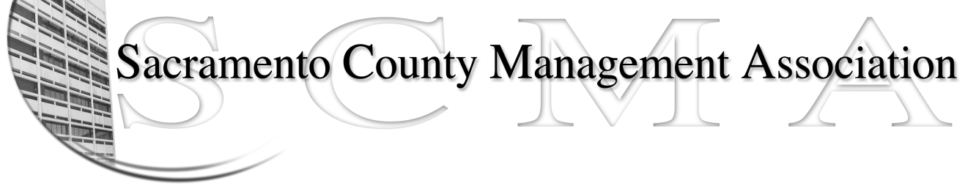

Kelsey Johnson, President Diana Ruiz, Vice-President
Jan Holm, Treasurer Nancy Gust, Secretary
Darcy Moehring, Board Member Kathy Bryan, Board Member
Pamela Harris, Board Member Vacancy, Board Member
Stephen Wallach, Board Member Vacant, Board Member
Bruce Coker, Board Member Vacant, Board Member

SCMA Board of Director’s Agenda
June 5, 2013 - 3:00 P.M.
9616 Micron Avenue, Suite 900 (Back of the complex)

- Introductions

- Review and approve the minutes from the May 1, 2013 Board of Director’s Meeting

- Treasurer’s Report – Jan

- Committee Reports
  - Association Meeting – Jan
  - Bylaws – Sue
  - Elections –Michelle/Kelsey
  - Website – Craig
  - Membership – Darcy
  - Discipline – Kathy
  - Meet & Confer – Diana

- Correspondence

- Old Business
  - Board of Director Ins Recommendation

- New Business
  - Negotiations
  - CSEA Partnership/LTD Insurance & other Member Benefits
  - Proposals for SCMA representation from CBM

- Adjournment

- Closed Session

