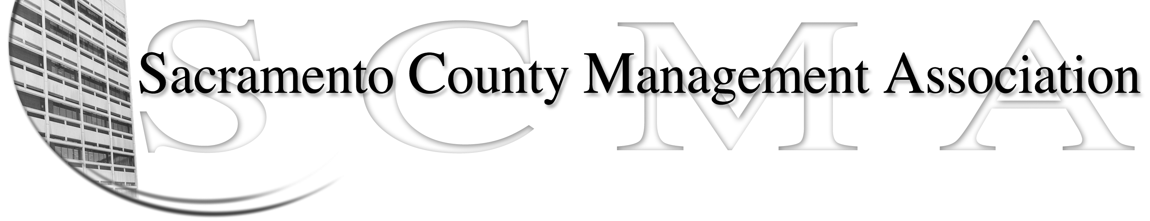

Kelsey Johnson, President Forrest Williams, Vice President
Nancy Gust, Secretary Piper Wilson, Treasurer
Sarah Britton, Board Member Brad Buyse, Board Member Sue Elliott Board Member Elizabeth Foster-Ward, Board Member John Hinkley, Board Member Jan Holm, Board Member
Kurt Mathews, Board Member Vacant, Board Member

SCMA Board of Director’s Minutes
June 1, 2011 – 3:00 P.M.
Sheriff’s Rockingham Station – 10361 Rockingham

Attendance: Kelsey Johnson, Brad Buyse, Elizabeth Foster-Ward, Jan Holm, Piper Wilson, Sue Elliott, Nancy Gust, Diana Ruiz (Proxy for Sarah Britton), Lynn Wynn (proxy for John Hinkley)

Absent: Forrest Williams, Kurt Matthews

Guests: Darcy Moehring, Cathy Girton, Craig Rader, Will Roman

- Introductions

- Minutes – Motion to approve May 4, 2011 Board of Director’s Minutes as corrected by Jan and seconded by Elizabeth. Ayes – All

- Treasurer’s Report – Handout

- Committee Reports
  - Association Meeting – Jan – November lunch menu available on website to make selection/reservation
  - By-Laws – Sue – Needs volunteers for reviewing/editing
  - Elections – Brad – Need written procedures for elections. Elections Committee will prepare report for changes to By-Laws
  - Website – Craig –
    - Stats were emailed to board members
    - Added MTO policy and notification that the Board of Supervisors approved our agreements May 24, 2011
    - Motion by Brad and seconded by Lynn to post the agreements on the website. Ayes - All
  - Membership – Nancy – Nine new members and two cancellations

  - Discipline – Lynn
    - Need some procedures for Grievances & Arbitration
    - Nancy will send Lynn and Elizabeth the Grievance form

  - Meet & Confer – Elizabeth
    - Still working on Dera, Economic Development
    - MSA/OCIT It merger will be in Fiscal Year 2012/13
    - Budget cuts to delete 8 CSO positions and leave 10 are still pending
    - Emergency Medical Services Administrator – Questions on what license(s) are required, MQ’s, Supervision. Is 5% bump enough? Meet & Confer might be necessary.

- Correspondence
  - CBM Invoice
  - Credit union statement
  - Newsletter from SCREA
  - IRS extension granted letter
  - Steve Keil – AB329

- Old Business – None

- New Business
  - Recognition of Board Members
    - Motion to adopt Recognition policy as drafted by Kelsey and seconded by Piper. Ayes – 8
  - Discrimination Policy (4.1.b)
    - Does not address all issues such as gender identity or sexual orientation. Need a side letter to correct
  - Joint Labor Meetings – Nancy will send out report on series of three meetings on budget and benefit issues

- Adjournment

- Closed Session

