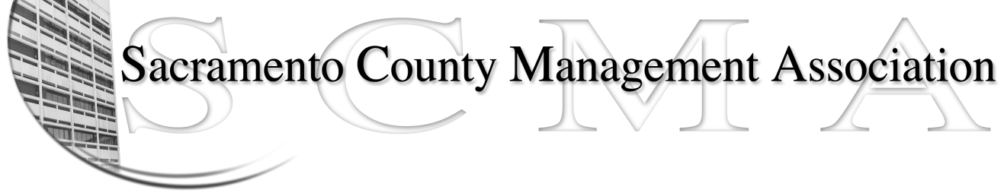

Kelsey Johnson, President Sue Elliott Board Member
Forrest Williams, Vice President Brad Buyse, Board Member
Nancy Gust, Secretary Elizabeth Foster-Ward, Board Member
Piper Wilson, Treasurer Jan Holm, Board Member
John Hinkley, Board Member Kurt Mathews, Board Member
Sarah Britton, Board Member Vacant, Board Member

SCMA Board of Director’s Agenda
June 1, 2011 - 3:00 PM
Rockingham Sheriff Station – 10361 Rockingham – Public Meeting Room

- Introductions

- Review and approve the minutes from the May 4, 2011 Board of Director’s Meeting.

II. Treasurer’s Report - Piper
  - Financial Report

- Committee Reports
  - Association Meeting - Jan
  - Bylaws - Sue
  - Elections - Brad
  - Website – Craig
  - Membership – Nancy
  - Discipline – Lynn
  - Meet & Confer - Elizabeth

- Correspondence
  - CBM invoice
  - Credit union statement

- Old Business

- New Business

- Adjournment

Closed Session

NOTE: CHANGE IN LOCATION FOR JULY MEETING
TO BE HELD AT THE RANCHO CORDOVA POLICE DEPARTMENT -
2897 KILGORE, RANCHO CORDOVA – 3:00 P.M. - 6:00 P.M.

