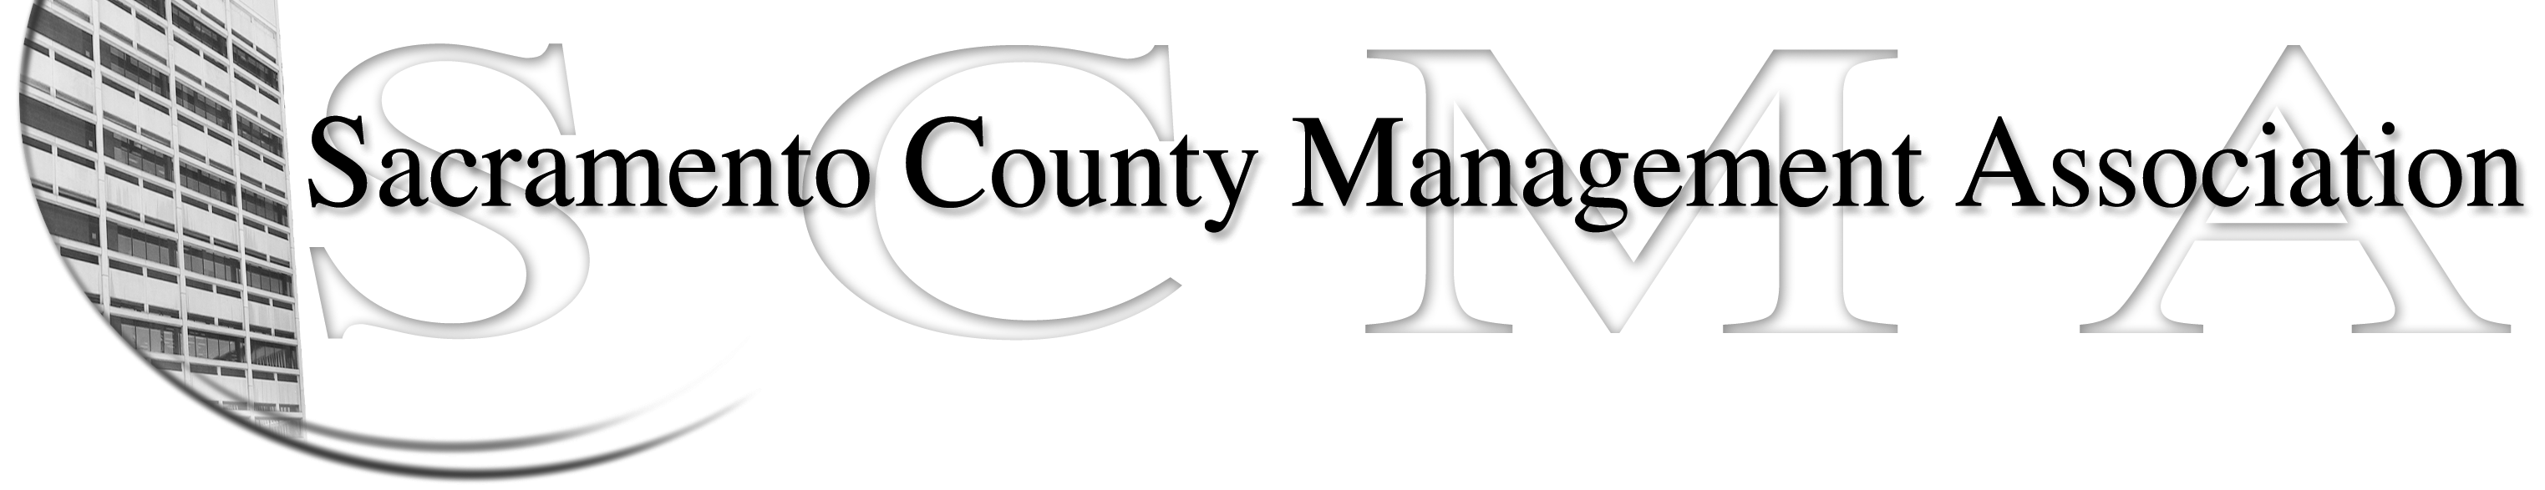

Kelsey Johnson, President Forrest Williams, Vice President
Nancy Gust, Secretary Piper Wilson, Treasurer
Sarah Britton, Board Member Brad Buyse, Board Member Sue Elliott Board Member Elizabeth Foster-Ward, Board Member John Hinkley, Board Member Jan Holm, Board Member
Kurt Mathews, Board Member Vacant, Board Member

SCMA Board of Director’s Minutes
May 4, 2011 - 3:00 P.M.
Sheriff’s Rockingham Station – 10361 Rockingham

Attendance: Diana Ruiz (proxy for Sarah Britton), Kelsey Johnson, Jan Holm, Elizabeth Foster-Ward, John Hinkley, Brad Buyse, Forrest Williams, Nancy Gust (3:30 p.m.), Piper Wilson (4:00 p.m.), Lynn Wynn (proxy for Brad 4:20 p.m.) , Sue Elliott

Absent: Kurt Mathews

Guests: Craig Rader, Mike Guiver, Lynn Wynn

- Minutes – Motion to approve minutes of April 6, 2011 Board of Directors meeting made by Sue and seconded by Brad. 6 Ayes; 1 Abstention - Motion carried

- Treasurer’s Report – Piper – discussed the report at the meeting and will email handout to all Board members

- Committee Reports
  - Association Meeting – Jan – Suggested putting the November 30th luncheon data on the website. Craig said it was on the calendar and as soon as menu is provided the RSVP notification will be setup
  - Bylaws – Need volunteers to start looking at by-laws for luncheon meeting. Sue will bring copies to the next meeting. Old by-laws will be moved to archives on website and new ones posted. Board members should review before the next meeting.
  - Elections – Brad –
    - Thanked his committee members John and Craig for their help with the on line voting setup.
    - Two votes taking place today, one for SDI and one for the tentative agreement.
    - Board of Directors voting will start tomorrow (May 5) and run through May 24th. Brad will notify Kelsey of results and she will notify new members and those that did not get selected.
    - Kelsey will also contact Labor Relations to see what they need to certify agreement and SDI results.
  - Website – Craig
    - E-mailed stats to board members prior to the meeting. He noticed a spike most likely due to correspondence going out about the tentative agreement. Hits were to main page, message board, home page and tentative agreement page.
    - Discussion on use of message board. Forrest made a motion to remove the message board from the website which Jan seconded. Ayes – All - Motion carried
  - Membership – Nancy – No report. Need more accurate lists for voting and membership
  - Discipline – No new actions
  - Meet and Confer – Elizabeth –
    - There are approximately 90 people involved in the OCIT/MSA IT merger. A meeting will be requested with merger employees to solicit concerns
    - May need a letter from Counsel over Meet & Confer issues.

- Correspondence – Documents received – Credit Union statement, post office box rent invoice and second notice. Lynn paid and will be reimbursed.

- Old Business – None

- New Business
  - Tentative agreement for SCMA – Needs some language clarified. Questions on
    - Grievances (which committee handles) – Discipline and Meet & Confer will handle. Need some SCMA grievance forms. Elizabeth will send a sample to Nancy to mock up.
    - HIL Payout not addressed in agreement (Section 8.1 Holidays) (See DSA 9.1 Holidays)
    - Reports on transfers/promotions in or out of SCMA and retirement/termination from SCMA. (See UPE Section 2.21
  - Capture ideas for next agreement with a form to be submitted at SCMA website. List will be compiled.

- Adjournment – 5:00 p.m.

- Closed Session

- Adjournment – 5:10 p.m.

