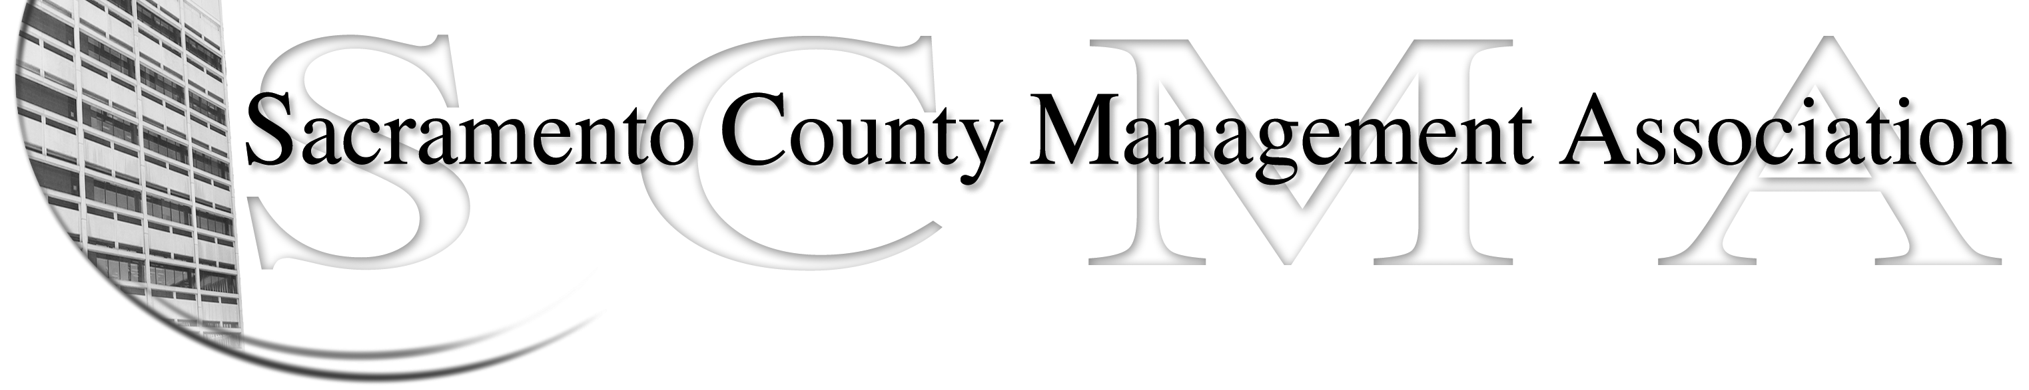

Kelsey Johnson, President Forrest Williams, Vice President
Nancy Gust, Secretary Jan Holm, Treasurer
Diana Ruiz, Board Member Darcy Moehring, Board Member Vacant, Board Member Elizabeth Foster-Ward, Board Member
Kathy Bryan, Board Member Cathy Girton, Board Member
Pamela Harris, Board Member Frances Worth, Board Member

SCMA Board of Director’s Minutes
May 2, 2012 – 3:00 P.M.
Office Building 3 – 3701 Branch Center Road
1st Floor Conference Room

Attendance: Forrest Williams, Nancy Gust, Diana Ruiz, Kathy Bryan, Cathy Girton, Jan Holm, Frances Worth

Absent: Elizabeth Foster-Ware, Kelsey Johnson, Darcy Moehring, Pamela Harris

Guests: John Hinkley, Sue Elliott. Craig Rader

- Introductions

- Minutes: Motion: Accept April 4, 2012 Board of Director Minutes by Diana and seconded by Kathy. Ayes – All

- Treasurers Report
  - Handouts – E-mailed to board members
  - SCMA 2012/13 budget was discussed and will be revised

- Committee Reports
  - Association – Jan – Date scheduled for the next business lunch at the Hilton – November 1, 2012

  - Bylaws –Sue/Diana – Bylaws vote was successful and they will be posted.

  - Elections – John/Craig – By e-vote the Board adopted the timeline for SCMA elections.

  - Website – Craig – E-mailed to Board members.
    - Updated SCMA block on email
    - Set up SCMA email accounts for Pamela and Frances
    - Need a picture of Frances
    - Updated bios on website
    - Short discussion about Twitter account

  - Membership – No report

  - Discipline – Nancy – Handed out report from Lynn

  - Meet & Confer – Diana
    - This committee needs a new Chair because Elizabeth is retiring.
    - CMID will have managers and inspectors together in one division as part of the re-organization. Side letter will protect seniority rights.
    - Class study for Custodial Manager and Emergency Medical Services Administrator.
    - Nurse Compaction – Two meetings with Labor Relations. Presented to Board on April 10, 2012. Waiting on PRA request.
    - Chief Investigator/Assistant Chief Investigator compaction issue at DHA.

- Correspondence

- Old Business
  - Cathy – No new information on Director’s & officers insurance

- New Business

- Adjourn 5:10 p.m.

