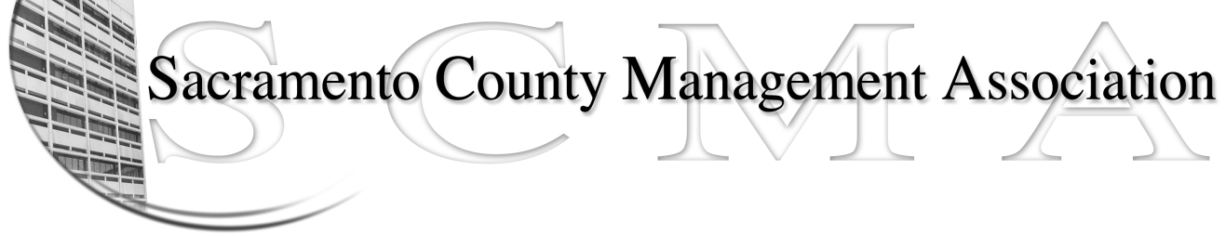

Kelsey Johnson, President Forrest Williams, Vice President
Nancy Gust, Secretary Jan Holm, Treasurer
Diana Ruiz, Board Member Darcy Moehring, Board Member Vacant, Board Member Elizabeth Foster-Ward, Board Member Kathy Bryan, Board Member Cathy Girton, Board Member
Frances Worth, Board Member Pamela Harris, Board Member

SCMA Board of Director’s Agenda
May 2 2012 - 3:00 P.M.
Office Building 3 – 3701 Branch Center Road
1st Floor Large Conference Room

- Introductions

- Review and approve the minutes from the April 4, 2012 Board of Director’s Meeting

- Treasurer’s Report – Jan
  - Financial Report
  - FY 2012-13 Budget

- Committee Reports
  - Association Meeting – Jan/Will
  - Bylaws – Sue
  - Elections – Kelsey/Roberta
  - Website – Craig
  - Membership – Darcy
  - Discipline – Lynn
  - Meet & Confer – Elizabeth

- Correspondence

- Old Business
  - LTD – Board of Director Ins Updates
  - Admin Analyst Series Class Study (30 mins)

- New Business

- Adjournment

- Closed Session

