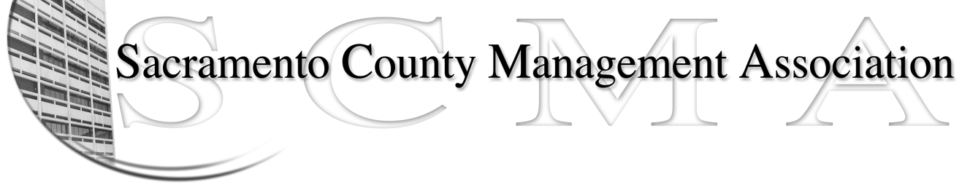

Kelsey Johnson, President Diana Ruiz, Vice-President
Jan Holm, Treasurer Nancy Gust, Secretary
Darcy Moehring, Board Member Kathy Bryan, Board Member
Pamela Harris, Board Member Vacancy, Board Member
Stephen Wallach, Board Member Vacant, Board Member
Bruce Coker, Board Member Vacant, Board Member

SCMA Board of Director’s Agenda
May 1, 2013 - 3:00 P.M.
9616 Micron Avenue, Suite 900 (Back of the complex)

- Introductions

- Review and approve the minutes from the April 3, 2013 Board of Director’s Meeting

- Treasurer’s Report – Jan

- Committee Reports
  - Association Meeting – Jan
  - Bylaws – Sue
  - Elections –Michelle/Kelsey
  - Website – Craig
  - Membership – Darcy
  - Discipline – Kathy
  - Meet & Confer – Diana

- Correspondence
  - E-mail regarding Probation Supervisor representation
  - E-mail regarding County Negotiation Assignments

- Old Business
  - Board of Director Ins Recommendation

- New Business
  - CBM proposal for providing services to SCMA

- Adjournment

- Closed Session

