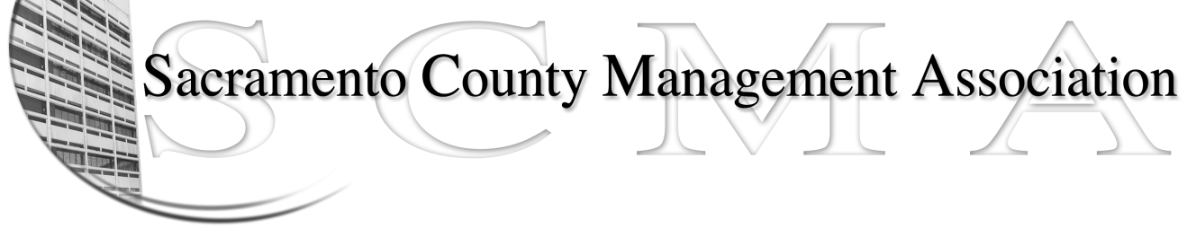
FOR IMMEDIATE RELEASE – April 30, 2010
Mike Guiver, President Craig Rader, Board Member
RoseMary Vaske, Vice President Brad Buyse, Board Member
Nancy Gust, Secretary Robert Nelson Board Member
Forrest Williams, Treasurer Bruce Coker, Board Member
Sue Elliott, Board Member

WE DID IT!!!!!
The Civil Attorneys Voted. We heard your voice loud and clear.

Sacramento County Management Association is now the Recognized Employee Organization for the Sacramento County Civil Attorneys!

Of the 43 ballots cast by eligible employees in 050, 27 voted YES for SCMA to be their Recognized Employee Organization.

Now that the election is over, the most important part begins, which is working on our Memorandum of Understanding (MOU) and our first contract with Sacramento County. Mike Guiver, SCMA President said “SCMA members will have the chance to help shape our future.” If you are interested in participating on a sub-committee, please contact one of the SCMA Board of Directors.

Each Board Member wishes to extend a heartfelt thanks to all of you who participated in this historic election and helped made it a reality. This could not have happened without each and every one of you!

If you are not a member, now is the time! Visit the SCMA website at scmamgt.org for news updates and a membership form.

Don’t forget our Summer Business Luncheon Meeting! Reserve the date!

SCMA’s semi-annual luncheon will be held at the Sacramento Hilton on June 24th. Registration begins at 11:15. Go to scmamgt.org now to make your reservation. SCMA members – free, non-members – $35.00

