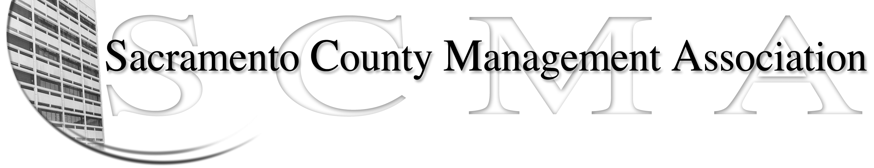

Mike Guiver, President Sue Elliott Board Member
RoseMary Vaske, Vice President Craig Rader, Board Member
Nancy Gust, Secretary Brad Buyse, Board Member
Forrest Williams, Treasurer Robert Nelson, Board Member
Bruce Coker, Board Member

DRAFT
SCMA Board of Director’s Agenda
12:30 P.M. – April 7, 2010
Voter Registration – 65th Street

- Review and approve the minutes from the March 3, 2010 meeting.

II. Treasurer’s Report - Forrest
  - Financial Report
  - Update on tax refund

III. Committee Reports
- Spring Luncheon – Sue
- Bylaws – 2010
- Elections – Brad
- REO – RoseMary
- REO – Campaign & Publicity - Sue
- Website - Craig

- Correspondence

- Old Business
  - Benefits study update - Craig
  - LTD update - Forrest
  - Compaction update - Sue
  - New member packet – Craig
  - Membership Dues - Al

- New Business
  - Review of the List of Duties & Committee Assignments for Board members
  - Brown bag meeting – Schedule
  - Nursing Compaction – RoseMary/Elizabeth
  - ALFAC request – Al – Deferred from March meeting
  - Request from Labor Relations to meet about FY 10-11 June budget mitigations – Mike
  - Salary Reduction by County Management Leaders - Mike

- Adjournment

