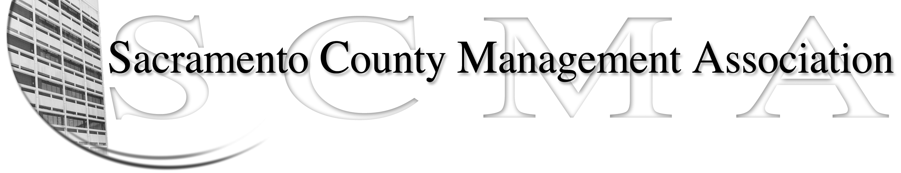

Kelsey Johnson, President Forrest Williams, Vice President
Nancy Gust, Secretary Piper Wilson, Treasurer
Sarah Britton, Board Member Brad Buyse, Board Member Sue Elliott Board Member Elizabeth Foster-Ward, Board Member John Hinkley, Board Member Jan Holm, Board Member
Kurt Mathews, Board Member Vacant, Board Member

SCMA Board of Director’s Minutes
April 6, 2011 - 3:00 P.M.
Sheriff’s Rockingham Station – 10361 Rockingham

Attendance: Lynn Wynn (for Sue Elliott), Kelsey Johnson, Jan Holm, Piper Wilson, Sarah Britton, Kurt Mathews, Elizabeth Foster-Ward, Nancy Gust, John Hinkley, Brad Buyse

Absent: Forrest Williams

Guests: Craig Rader, Mike Guiver, Hu

- Minutes – Motion to approve minutes of March 2, 2011 Board of Directors meeting made by Lynn and seconded by Elizabeth. Ayes 10.

- Treasurer’s Report – Piper. Handout presented

- Committee Reports
  - Association Meeting – Jan – Business Meeting Lunch scheduled for Wednesday November 30 at the Hilton.
  - Bylaws – No report.
  - Elections - Brad
    - Only two nomination forms received so far. Mike said he had one to submit.
    - County Counsel reps are actively looking for someone to nominate. Sarah Britton will not be able to continue for the next term.
  - Website – Craig
    - E-mailed stats to board members and discussed in meeting
    - Will be updating the disclaimer on the “Message Board”
  - Membership – Nancy.
    - Reported on new members and cancellations. Also have names dropping off because of retirements
    - Passed out CD’s with members/non-members to be used for recruiting. Craig will also be comparing against his list.
  - Discipline – Closed Session.
  - Meet and Confer – Elizabeth –
    - Discussed on-going meetings and items that have been closed.
    - Will be looking into OCIT/MIS merger.

- Correspondence – Documents received - None

- Old Business – None

- New Business
  - Public Employees Wages and Pensions – Sarah
    - Wages - presented information she had found on wage studies and pensions. Per a study done by Berkeley public employees are not overpaid. No clear information on fringe benefits or retiree health benefits
    - Pensions – It does not appear that the public employee pensions are highly overpaid also.
    - A list of talking points will be made up for wage and pension topics
  - DHHS – Lynn – Received a copy of the Conflict of Interest Policy and form. Several other departments have Conflict of Interest policies. The form seems to go beyond the scope of the policy. Elizabeth is going to request an informal Meet and Confer with the Department Head
  - New County Executive – Filing date closed March 28, 2011
  - Guest Speaker – Hu – Treatment Center Standby Plan – He presented his concerns regarding the Standby Plan. It will also be addressed in the Meet & Confer with DHHS.

- Adjournment – 5:30 p.m.

- Closed Session

XII. Adjournment 5:45 p.m.

