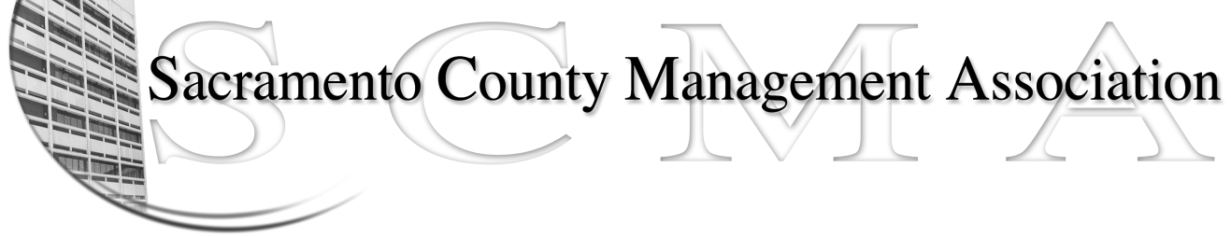

Kelsey Johnson, President Sue Elliott Board Member
Forrest Williams, Vice President Brad Buyse, Board Member
Nancy Gust, Secretary Elizabeth Foster-Ward, Board Member
Piper Wilson, Treasurer Jan Holm, Board Member
John Hinkley, Board Member Kurt Mathews, Board Member
Sarah Britton, Board Member Vacant, Board Member

SCMA Board of Director’s Agenda
April 6, 2011 – 3:00 PM
Rockingham Sheriff Station – 10361 Rockingham – Public Meeting Room

- Review and approve the minutes from the March 2, 2011 Board of Director’s Meeting.

II. Treasurer’s Report - Piper
  - Financial Report

- Committee Reports
  - Association Meeting - Jan
  - Bylaws - Sue
  - Elections - Brad
  - Website – Craig
  - Membership – Nancy
  - Discipline – Lynn
  - Meet & Confer - Elizabeth

- Correspondence

- Old Business

- New Business
- Report back on Public employee unions and pensions
- Informational – Status of Proposed reorganizations
- DHHS – Conflict of Interest Policy
- New County Executive
- Treatment Center – Standby Plan

- Adjournment

Closed Session

