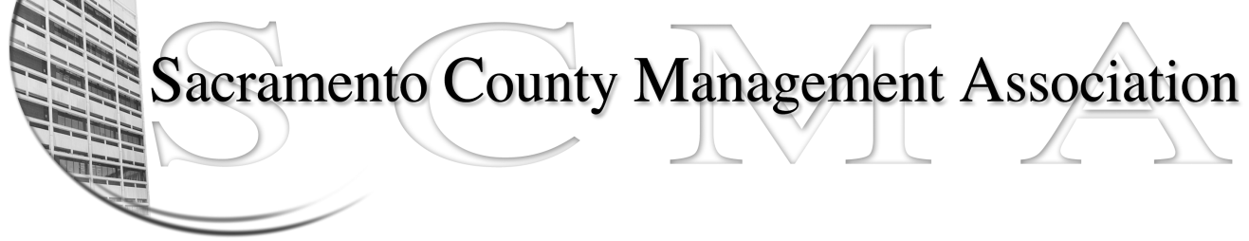

Kelsey Johnson, President Diana Ruiz, Vice-President
Jan Holm, Treasurer Nancy Gust, Secretary
Darcy Moehring, Board Member Kathy Bryan, Board Member
Pamela Harris, Board Member Vacant, Board Member
Stephen Wallach, Board Member Vacant, Board Member
Bruce Coker, Board Member Vacant, Board Member

SCMA Board of Director’s Agenda
April 3, 2013 - 3:00 P.M.
9616 Micron Avenue, Suite 900 (Back of the complex)

- Introductions

- Review and approve the minutes from the March 6, 2013 Board of Director’s Meeting

- Treasurer’s Report – Jan

- Committee Reports
  - Association Meeting – Jan
  - Bylaws – Sue
  - Elections – Michelle
  - Website – Craig
  - Membership – Darcy
  - Discipline – Kathy
  - Meet & Confer – Diana

- Correspondence

- Old Business
  - LTD – Board of Director Ins Update
  - Election Procedures

- New Business
  - Alternative use(s) of Big Pulse if election is not required (John Hinkley)

- Adjournment

- Closed Session

