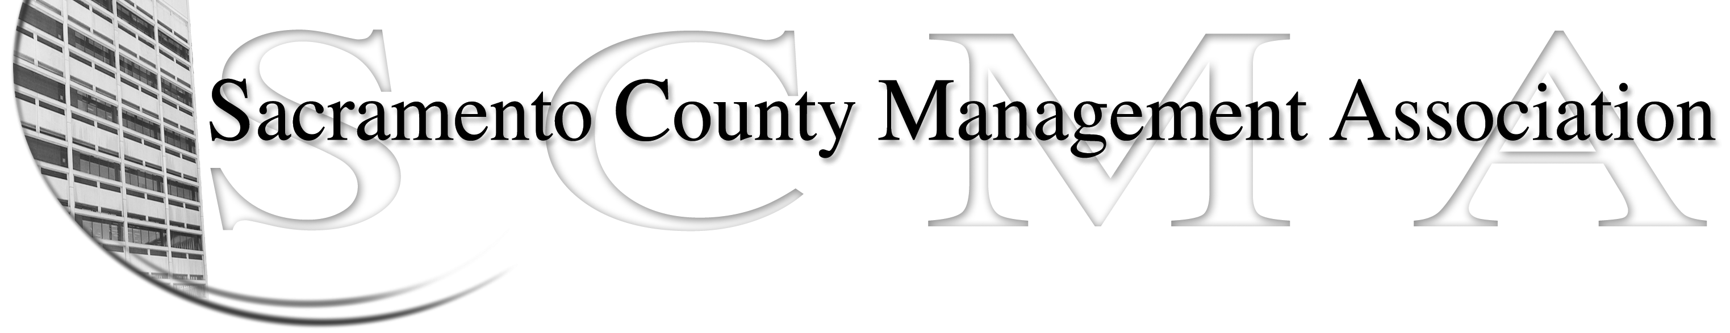
Phil Fiscbach, President |  | Nancy Gust
Sue Elliott, Vice President |  | Mike Guiver
RoseMary Vaske, Secretary |  | Robert Nelson
Forrest Williams, Treasurer |  | Craig Rader
Al Mateer, Past President |  | Brad Buyse
 |  | Vacant

SCMA Board of Director’s Minutes

Special Meeting on March 31, 2009 – 1:10 P.M.

Attendees: Sue Elliott, Nancy Gust, Mike Guiver, Robert Nelson, Craig Rader, Brad Buyse,

Phil Fischbach, RoseMary Vaske

Absent: Al Mateer and Forrest Williams

- Phil reminded the members that the purpose of the special meeting is to work on a revision and updating of the SCMA bylaws.
- Following discussion it was agreed to by all members present to eliminate the position of past president in the draft of the bylaws.
- Following discussion it was agreed to by all members present to change the groupings to three from five. The three groupings will represent the three County agencies and there will be three representatives from each of the three County agency groupings for a total of nine SCMA board members. And, there will be no more than two elected or appointed members from any one department within an agency.
- Following discussion it was agreed that five members will be elected in odd number years and four members in even number years beginning with the 2010 election.
- Following discussion it was agreed that if you cannot attend a SCMA Board Meeting you may have a SCMA dues paying member in good standing attend and vote in your place. An associate member cannot fill this role.
- Following discussion the members agreed to include the role of Parliamentarian in the purposed bylaws.
- Robert lead the discussion through the purposes changes being presented by the Bylaws Subcommittee composed of Robert Nelson, Sue Elliott and RoseMary Vaske. A copy of the purposed changes agreed to during the course of this Special Meeting is attached to these minutes.
- Nancy is to check with Forrest to see if any members write a check for their annual dues rather than pay by payroll deduction. There is a need to clarify how this is handled through Payroll and for membership tracking purposes.
- The meeting adjourned at 3:35 P.M.

