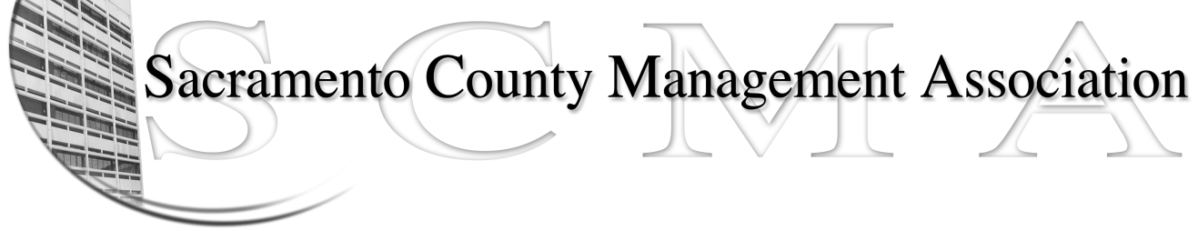

Kelsey Johnson, President Forrest Williams, Vice President
Nancy Gust, Secretary Jan Holm, Treasurer
Diana Ruiz, Board Member Darcy Moehring, Board Member Will Roman, Board Member Elizabeth Foster-Ward, Board Member Kathy Bryan, Board Member Cathy Girton, Board Member
Vacant, Board Member Vacant, Board Member

SCMA Board of Director’s Agenda
March 7, 2012 - 3:00 P.M.
Office Building 3 – 3701 Branch Center Road
Large Conference Room

- Introductions

- Review and approve the minutes from the February 1, 2012 Board of Director’s Meeting

- Treasurer’s Report – Jan
  - Financial Report

- Committee Reports
  - Association Meeting – Jan/Will
  - Bylaws – Sue
  - Elections – Kelsey
  - Website – Craig
  - Membership – Darcy
  - Discipline – Lynn
  - Meet & Confer – Elizabeth

- Correspondence

- Old Business
  - Cancellation of LTD policy
  - Bylaws discussion

- New Business
  - Bylaw vote date selection
  - Election Chair appointed by President
  - Nurse compaction

- Adjournment

- Closed Session

