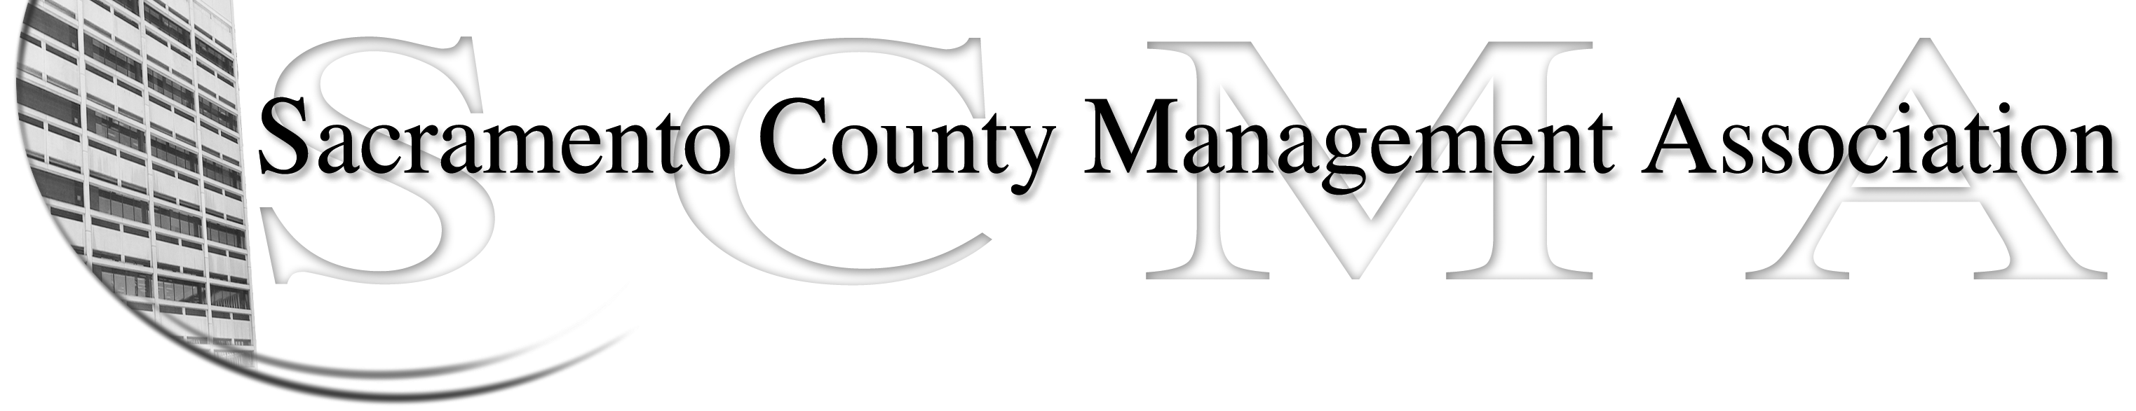

Mike Guiver, President Sue Elliott Board Member
RoseMary Vaske, Vice President Craig Rader, Board Member
Nancy Gust, Secretary Brad Buyse, Board Member
Forrest Williams, Treasurer Robert Nelson, Board Member
Bruce Coker, Board Member

SCMA Board of Director’s Agenda
12:30 P.M. – March 3, 2010
Voter Registration – 65th Street

- Review and approve the minutes from the February 3, 2010 meeting.

II. Treasurer’s Report - Forrest
  - Financial Report
  - Update on tax refund

III. Committee Reports
  - Membership / Spring Luncheon – Sue
    - Spring Luncheon
    - Pictures for website
- Bylaws – 2010
- Elections – Brad
- REO – RoseMary
- REO – Campaign & Publicity - Sue
- Website - Craig

- Correspondence

- Old Business
  - Benefits study update - Craig
  - LTD update - Forrest
  - Compaction update - Sue
  - New member packet – Craig
  - Membership Dues - Al

- New Business
  - Review of the List of Duties & Committee Assignments for Board members
  - Brown bag meeting – Schedule
  - Meeting with Steve Szaley – Results
  - Nursing Compaction – RoseMary
  - ALFAC request

- Adjournment

