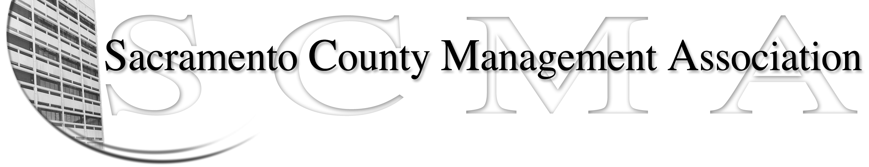

Kelsey Johnson, President Forrest Williams, Vice President
Nancy Gust, Secretary Piper Wilson, Treasurer
Sarah Britton, Board Member Brad Buyse, Board Member Sue Elliott Board Member Elizabeth Foster-Ward, Board Member John Hinkley, Board Member Jan Holm, Board Member
Kurt Mathews, Board Member Vacant, Board Member

SCMA Board of Director’s Minutes
March 2, 2011 - 3:00 P.M.
Sheriff’s Rockingham Station – 10361 Rockingham

Attendance: Lynn Wynn (for Brad Buyse), Kelsey Johnson, Forrest Williams, Jan Holm, Sue Elliott, Piper Wilson, Sarah Britton, Kurt Mathews, Elizabeth Foster-Ward, Nancy Gust, John Hinkley (via phone)

Absent:

Guests: Craig Rader, Mike Guiver, Shelly Orio

- Minutes – Motion to approve minutes of February 2, 2011 Board of Directors meeting with corrections made by Jan and seconded by Kelsey. Ayes 10.

- Treasurer’s Report – Piper. No report. Forrest and Piper still working on transitioning.

- Committee Reports
  - Association Meeting – Jan and Sue. The board discussed the idea of having only one luncheon meeting in early December (i.e. 1st week). It would be a time to update members on what has happened in the past year and what is expected in the new year. Jan will contact the Hilton for potential dates.
  - Bylaws – Sue. No report at this time; looking for committee members.
  - Elections – Lynn (for Brad)
    - Distributed election calendar. After discussion and edits, the dates were agreed upon.
    - How to vote was also discussed: paper versus electronic format. Craig was aware of one vendor and John stated that the Deputy Sheriff’s Association hired a 3rd party to handle elections and was given a report with the results. Separate logons were mailed to each person. John will research.
    - Motion made by Sue for Election Committee to determine what is most financially feasible & confidential with a budget not to exceed $800. Motion seconded by John. Ayes - 11
  - REO – No report.
  - Website – Craig
    - Report on statistics was handed out.
    - Website was updated to reflect new Board of Director members. SCMA is now also on Twitter.
    - Craig presented idea of developing a mobile website. Would cost $72.00 a year on current website. Decision made to hold off and discuss later when there are less expenses.
    - Website renewal is due in 2012; options will be explored.
  - Membership – Nancy. No new report. List of members/non-members will be sent to all Board members to assist them with recruitment.
  - Discipline – Closed Session.
  - Meet and Confer – Elizabeth and Forrest. Reorganization of IT positions in Finance and Clerk Recorders Office. Economic Development and MSA also re-organizing. Discussion on involuntary moves during a re-organization with more to follow. Create a list of “What is a Meet and Confer”.

- Correspondence – Documents received:
  - Sacramento County Retirees Association newsletter.
  - Sacramento County Administrative Professionals Association (Unit 060) – received 30% of membership so they will be going to a vote for REO.
  - Data Processing Professionals Association (Unit 028) vote is April 6th and 7th, 2011.

- Old Business – None

- New Business
A. Sarah is researching public employees forming unions and also looking at pensions. Fact gathering will assist us when making presentations or when contacted by the press.

- Adjournment – 5:28 p.m.

- Closed Session

- Open Session (5:45 p.m.) – Kelsey, Jan, Sue, Piper, Elizabeth, Kurt, Nancy, John, Lynn (for Brad)
Motion made by Sue to authorize the President to approve spending up to two (2) hours of counsel consulting services time per month, between SCMA Board meetings, for use by the Discipline Committee, with a report back to the Board at the next meeting. Seconded by Elizabeth. Ayes 9

XII. Adjournment 5:55 p.m.

