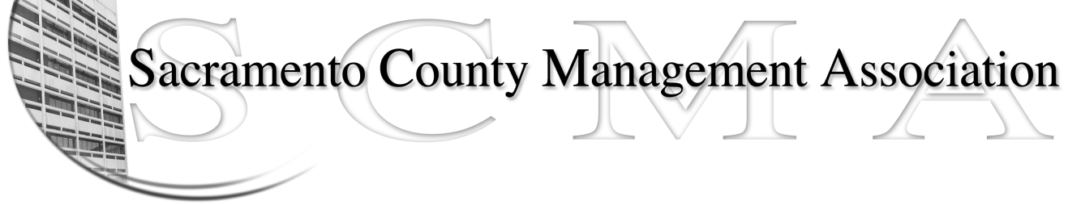

Kelsey Johnson, President Sue Elliott Board Member
Forrest Williams, Vice President Brad Buyse, Board Member
Nancy Gust, Secretary Elizabeth Foster-Ward, Board Member
Piper Wilson, Treasurer Jan Holm, Board Member
Sarah Britton, Board Member Vacant, Board Member

SCMA Board of Director’s Agenda
March 2, 2011 – 3:00 PM
Rockingham Sheriff Station – 10361 Rockingham – Public Meeting Room

- Review and approve the minutes from the February 2 2011 Board of Director’s Meeting.

II. Treasurer’s Report - Piper
  - Financial Report

- Committee Reports
  - Association Meeting - Jan
  - Bylaws - Sue
  - Elections - Brad
  - Website – Craig
  - Membership – Nancy
  - Discipline – Lynn
  - Meet & Confer - Elizabeth

- Correspondence

- Old Business

- New Business

- Adjournment

Closed Session

