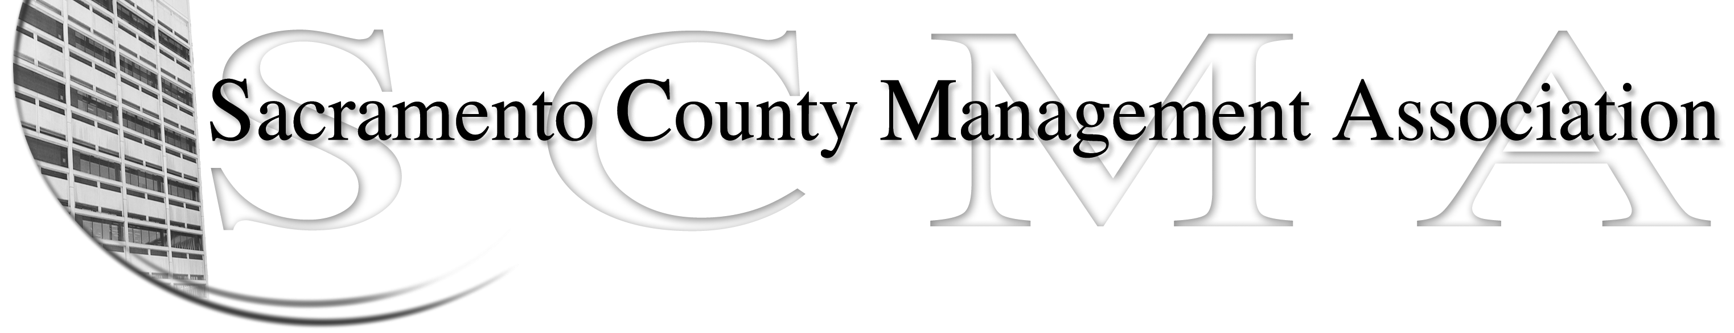
Phil Fischbach, President |  | Nancy Gust
Sue Elliott, Vice President |  | Mike Guiver
RoseMary Vaske, Secretary |  | Robert Nelson
Forrest Williams, Treasurer |  | Craig Rader
Al Mateer, Past President |  | Brad Buyse
 |  | Vacant

SCMA Board of Director’s Minutes

February 17, 2009

Attendance: Phil Fischbach, Sue Elliott, Mike Guiver, Robert Nelson, Craig Rader, Brad Buyce, Nancy Gust and RoseMary Vaske.

Guests: Lynn Wynn, Diana Gin and Richard Maddox

- Approval of Minutes from the December 16, 2008 and January 17, 2009 meetings. Sue moved to approve the minutes as written for December 2008 and January 2009; Nancy seconded. AYES-all, NAYS-none, ABSTENTIONS-none.

- Treasurer’s report – The update on the late IRS tax filings for prior years was presented. Forrest and Mike will make an appointment to meet with a representative from the IRS to see if some of the penalty can be waived. It appears that the late filing penalty is currently about $400 for 2006 and $953 for 2005. Sue moved to approve the Treasurer’s report and Mike seconded. AYES-all; NAYS–none, ABSTENTIONS-none.

- Special project – 2009 calendar with assignments and duties – See attachment to minutes.

- Committee Reports

  - Website Update – The website is current at this time.
  - Spring luncheon – Sue is finalizing the dates for the two 2009 luncheons. The next luncheon will be on May 21st. Brad, RoseMary and Mike will assist with the registration process, Nancy will create the RSVP list, Mike will purchase the 10 raffle prizes. Board members should try to arrive about 11:15 a.m. and the lunch is to be available at 11:45 a.m. We will try again to collect personal email addresses.

- Correspondence – No correspondence this month.

- Board vacancy – Discussion took place noting the importance of filling the vacancy according to the current bylaws. This is a topic that needs to be updated during the bylaws review process as the County departments change names over the years and the grouping arrangement may not be relevant at this juncture. Sue made a motion to postpone a decision until the March meeting; Forrest seconded. AYES-Sue, Nancy, Phil, Mike, Brad, Craig, and Forrest; NAYES-RoseMary; ABSTENTIONS-none. The final decision on who should fill the vacancy will be limited to ten minutes and was deferred until the March meeting.

- Old Business

  - Benefits (RFP) survey update - Forrest, Brad and Mike will be attending the meeting with the Department of Personnel Services on Wednesday. They will provide an update next month.
  - Salary compaction issue and the Grace Consulting Report – Since we have not received a response to the letter we sent to the County Executive last fall we will move forward with communicating with the Board of Supervisors. Phil is to draft a letter for members to review. The Excel information highlighting some of the areas were compactions issues exist will be sent along with the letter to the BOS for their information.

  - LTD update – Lynn reported that she was notified by Joel that March is open enrollment month. Following discussion it was decided that Lynn and Forrest would talk with Joel to ascertain what options are available for the approximately 40 managers and then we will need to send a letter to the impacted managers to notify them that we will not be able to continue to provide support for this insurance program in the future and provide them with the name and contact phone number to discuss options directly with the LTD local agent.
  - SCMA’s response to County budget planning – We will be sending a postcard to all members of management (members and non-members) inviting them to complete an online survey using Survey Monkey to help us identify the members’ preferences so we will have that information available as we continue to participate in meeting with Labor Relations.
  - Review / update bylaws – The goal is to have the committee complete their review and be prepared to present their suggestions at the March meeting.

- New Business

  - Phil and Mike will be meeting with Jan Scully in the afternoon. They will provide an update at the next meeting.
  - Equity study results – Phil is to send a letter to the Department of Personnel Services asking for information on their plan for 2009. We have not received any information to date for this year’s survey.
  - Email etiquette – RoseMary expressed concern about the content and emotions included in some of the emails that have been sent during the last month. Members discuss the importance of using discretion in sending emails using the County’s email system.

