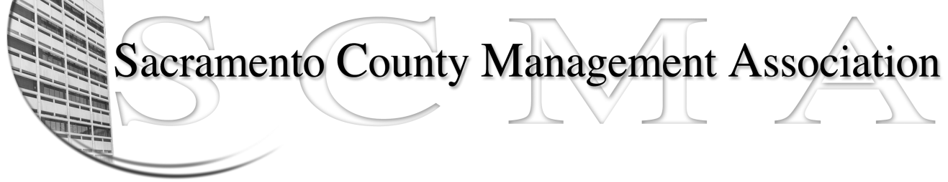

Kelsey Johnson, President Diana Ruiz, Vice-President
Jan Holm, Treasurer Nancy Gust, Secretary
Frances Worth, Board Member Darcy Moehring, Board Member
Pamela Harris, Board Member Cathy Girton, Board Member
Stephen Wallach, Board Member Kathy Bryan, Board Member
Bruce Coker, Board Member Vacant, Board Member

SCMA Board of Director’s Minutes
February 6, 2013 - 3:00 P.M.
9616 Micron Avenue, Suite 900

Attendance: Diana Ruiz (proxy for Cathy), Jan Holm (proxy for Frances), Nancy Gust, Mike Guiver (proxy for Kathy), Lynn Wynn (proxy for Darcy), Pamela Harris (3:08 pm), Bruce Coker (3:30 pm), Kelsey Johnson (3:52 pm)

Absent: Stephen Wallach

Guests: Linda Dorn, Craig Rader, Kathleen Macias, Matt Quinley, Lisa Scott-Lee, Michelle Schuhmann

- Introductions

- Minutes: Motion: Approve Jan 2, 2013 Board of Directors Minutes as written by Jan and seconded by Diana. Ayes – 7

- Treasurer’s Report – Report provided

- Committee Reports
  - Association Meeting – No report
  - Bylaws – Sue/Diana - No report
  - Elections – Diana/Kelsey
    - Motion: Approve expenditure for electronic voting (Big Pulse) not to exceed $800.00 by Jan and seconded by Lynn. Ayes – 10
  - Website – Craig - E-mailed
  - Membership – Darcy/Craig
  - Discipline – Kathy/Lynn - Report provided
    - Cindy Sawhill will be stepping down from the committee. Anyone interested should contact Kathy Bryan
  - Meet & Confer – Diana - Report provided
    - Motion: If Supervising Probation Officers create a separate bargaining unit that SCMA not represent them by Diana and seconded by Kelsey. Ayes - 10

- Correspondence
SCMA Board of Directors Meeting Minutes – February 6, 2013 Page 2

- Old Business
  - Board of Director Insurance Update – No report

- New Business
  - Audit Committee – Mike Guiver – Presented report. The committee had no Findings but did have some Recommendations.
    - Have President or other Board member sign approved minutes
    - Treasurer should record “Received” date on invoice when received
    - Profit & Loss statement should include year-to-date, annual budget and variances between.
  - Annual Salary Compensation Review – A Public Records Request will be submitted to ask for the most recent copy.
  - Grace Consulting Report – Also submit a Public Records Request for a copy of this report. Deals with Nurse/Mental Health Planner compaction

- Adjourn 5:35 p.m.

- Closed Session

Final Minutes (as approved at the March 6, 2013 meeting)
JH 3/27/13

