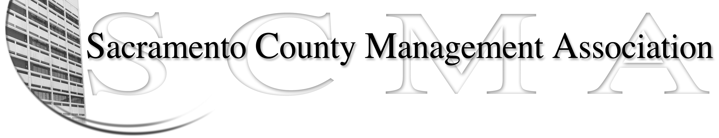

Mike Guiver, President Sue Elliott Board Member
RoseMary Vaske, Vice President Craig Rader, Board Member
Nancy Gust, Secretary Brad Buyse, Board Member
Forrest Williams, Treasurer Robert Nelson, Board Member
Bruce Coker, Board Member

SCMA Board of Director’s Minutes
9:30 A.M. – February 3, 2010
Voter Registration – 65th Street

Attendance: Sue Elliott, Rosemary Vaske, Brad Buyse, Mike Guiver, Craig Rader, Nancy Gust, Bruce Coker, Robert Nelson, Forrest Williams

Absent: None

Guests: Lynn Wynn, Kathleen Macias, Robert Stovall

- Review and approve the minutes from the January 12, 2010 meeting. Brad made motion to approve minutes as corrected and RoseMary seconded.
Ayes – All Motion carried

II. Treasurer’s Report - Forrest
  - Financial Report – Handout #1. submitted – Questions for Forrest - Is a deposit missing and why the negative Net Income? Forrest explained when he got to meeting that no deposit was missing. Issue was the cut off date for this report.
  - Update on tax refund – No news

III. Committee Reports
  - Membership / Spring Luncheon – Sue
    - Program for Spring Luncheon
      - Ask Steve Szalay to be Key Note speaker
      - REO Process
      - RFP results
    - Pictures for website
      - Postponed till March
- Bylaws – 2010
  - No update
- Elections – Brad
  - Brad, Bruce and Lynn will work on procedures
- REO – RoseMary
  - Handout #1 on Subcommittee actions
  - Handout #2 on examples of Manager relationships
  - Arbitration will be March 2, 2010. Should have results in ten days. Special Meeting set for 3/19/10 to discuss results.
  - Soonest date for REO election appears to be April 10, 2010.
- REO – Campaign & Publicity – Sue
  - Johnny Terry has volunteered to help with distributing information. Other volunteers will be needed and can contact Sue.
- Website – Craig
  - Handout #1Website hits and information
  - Bruce volunteered to be Backup support for Website.

- Correspondence
  - Tax document to Forrest

- Old Business
  - Benefits study update – Craig
    - Nancy to call Jim Cooper about Elk Grove HR participation
  - LTD update – Forrest
    - Forrest contacted broker about distribution of open enrollment LTD information. Craig has the address list. Forrest will get flyer from broker which will then be distributed by SCMA. Broker will reimburse any costs.
    - Forrest thinks there will be some cancellations of LTD and will also secure rooms for the LTD update sessions.
  - Compaction update – Sue
    - Compaction item went to the Board of Supervisors on January 26th and no one from the SCMA Board was able to be there. Note: members of the SCMA Board had met with David Devine and staff prior to January 26th to review Mr. Devine’s written presentation to the BOS on this topic.
    - One issue raised by Roger Dickinson was where was it in writing about changing the policy from 10% to 7% spread for the difference between subordinate classes and managers. SCMA did not agree to the 7% spread. Sue and Mike will draft a response to Board of Supervisors. Motion made by Bruce and seconded by Craig. Ayes – All. Motion carried.
  - New member packet – Craig
    - New packet handed out. Corrections to be made in Intro section. Meeting dates and time will be corrected. Definition of SCMA will be added. E-mail Craig with any additional changes.
  - Membership Dues – Lynn
    - No update. Lynn will send Al the REO dues worksheet.

- New Business
  - Review of the List of Duties & Committee Assignments for Board members
    - Tabled till March
  - Brown bag meeting – Schedule – with Nav
    - Meetings to be scheduled quarterly
    - Topics to include: Introduction of Steve Szalay, Budget Update, Compaction Update, REO Process.
  - Meeting with Steve Szalay – Create agenda
    - Agenda to include asking Steve to be Key Note Speaker at May lunch, Brown Bag Quarterly meetings, Workload, REO Process, carve out process.
      - SCMA may want to meet with Leadership Team
      - May want to also include a short SCMA history
      - Ask why there are still funded vacant positions.

- Adjournment – 2:15 p.m.

