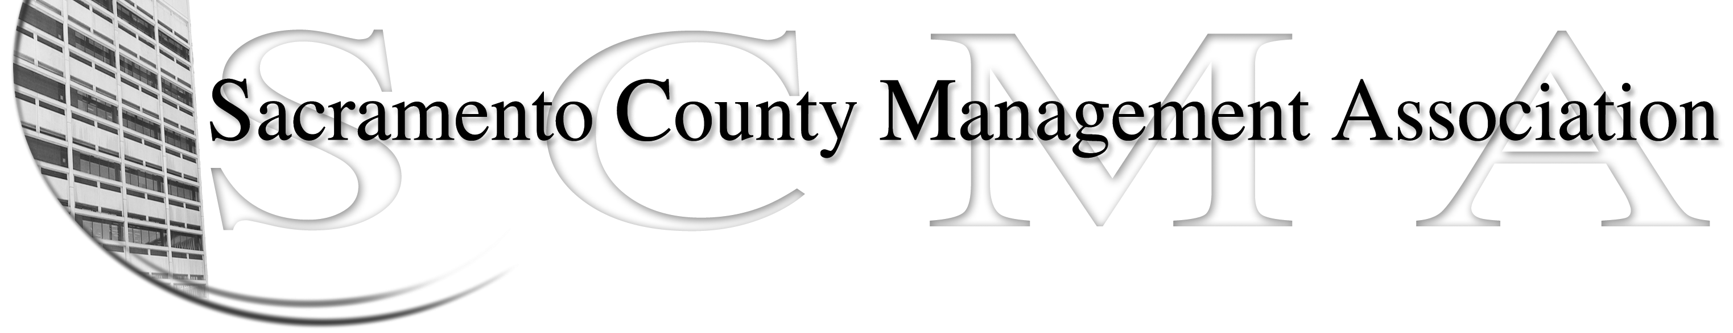

Kelsey Johnson, President Forrest Williams, Vice President
Nancy Gust, Secretary Piper Wilson, Treasurer
Vacant, Board Member Brad Buyse, Board Member
Sue Elliott Board Member Elizabeth Foster-Ward, Board Member
Vacant, Board Member Jan Holm, Board Member
Vacant, Board Member Scotte Trudeau, Board Member (fka Robert Nelson)

SCMA Board of Director’s Minutes
February 2, 2011 - 3:00 P.M.
Sheriff’s Rockingham Station – 10361 Rockingham

Attendance: Brad Buyse, Kelsey Johnson, Forrest Williams, Jan Holm, Sue Elliott, Piper Wilson, Nancy Gust

Absent: Elizabeth Foster-Ward, Scotte Trudeau

Guests: Kurt Mathews, Sarah Britton, John Hinkley, RoseMary Vaske, Mike Guiver

- Minutes – Motion to approve minutes of January 5, 2011 Board of Directors meeting with corrections made by Kelsey and seconded by Brad. Ayes 10. Motion made to approve minutes as corrected for the January 13, 2011 Business Meeting by Forrest and seconded by Jan. Ayes 10 (Minutes were approved out of order in agenda)

- Treasurer’s Report – Forrest presented the updated financial reports. Forrest and Piper are working together on transitioning the job duties.

- Committee Reports
  - Business Lunch –Sue- gave a report on Business Lunch. 175 RSVP’s were received and the expenditures were $4,900 for lunch and $188 for raffle prizes. CBM donated tickets to a Kings game
  - Bylaws – The revised Bylaws were passed at the Business Lunch with a vote of 120-4 with one under vote. One correction was made at the lunch to switch from calendar to fiscal year.
  - Elections – No new information
  - REO – There were 3 joint bargaining meetings in January and 2 are scheduled for February plus numerous work meetings
  - Website – Report was sent to committee members by e-mail
  - Membership – Nancy – update on new applications and cancellations

- Correspondence – Documents received:
  - Article from Wall Street Journal on negotiations for government workers at the management level which will be posted to the website.

- Old Business – None

- New Business
  - Committee Chair selection
    - Website – Craig Rader
    - Association Meetings – Jan Holm
    - By Laws – Sue Elliott
    - Membership – Nancy Gust
    - Elections – Brad Buyse
    - Audit – Still to be determined
  - Three Open Board Seats – Since the revised bylaws were passed at the January 13, 2011 meeting there are 3 open Board of Director seats; 2 general and 1 for County Counsel. Kelsey made a motion to appoint Sarah Britton from County Counsel for that seat and Nancy seconded. Ayes – 7. Sue made a motion to appoint Kurt Mathews (Fire Operations) to the second seat which was seconded by Kelsey. Ayes – 8. Sue made a motion to appoint John Hinkley (Sheriff’s Department) for the 3rd seat which was seconded by Brad. Ayes – 9.
  - Additional Committees - There will also be a Discipline Committee with Lynn Wynn as Chair with Cindy Sawhill as a member and a Meet & Confer Issues – Chaired by Elizabeth Foster-Ward.
  - Honorary Member - Kelsey made a motion to recommend RoseMary Vaske as an Honorary Member which was seconded by Sue. Ayes - 10
  - Report on Joint Reo Meeting – January 26, 2011, 3:00 p.m., MSA Conf Room (Traffic Way). Negotiations to start with other REO’s soon. The County wants to add new retirement tiers to the agreements, no cola’s or equities. They also want furlough language in all agreements
  - Motion made by Forrest and seconded by Sue to allow Mike and RoseMary to attend the Closed Session because they had relevant information. Ayes - 10
IX. Adjournment – 4:23 p.m.

