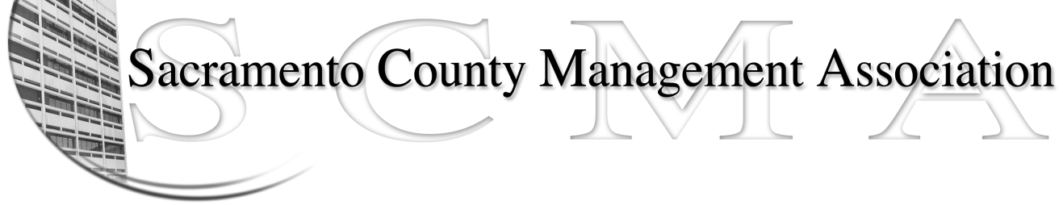

Kelsey Johnson, President Sue Elliott Board Member
Forrest Williams, Vice President Brad Buyse, Board Member
Nancy Gust, Secretary Scotte Trudeau, Board Member
Piper Wilson, Treasurer Jan Holm, Board Member
Elizabeth Foster-Ward, Board Member

SCMA Board of Director’s Agenda
February 2, 2011 – 3:00 PM
Rockingham Sheriff Station – 10361 Rockingham – Public Meeting Room

- Review and approve the minutes from the January 5, 2011 Board of Director’s Meeting and the January 13, 2011 General Meeting.

II. Treasurer’s Report - Forrest
  - Financial Report

- Committee Reports
  - Business Luncheon - Sue
  - Bylaws
  - Elections
  - REO
  - Website – Craig
  - Membership recruitment - Nancy

- Correspondence

- Old Business

- New Business

- Adjournment

Closed Session

