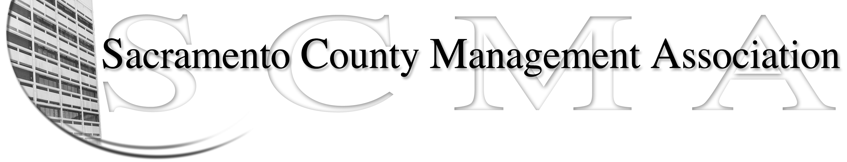

Kelsey Johnson, President Forrest Williams, Vice President
Nancy Gust, Secretary Jan Holm, Treasurer
Diana Ruiz, Board Member Darcy Moehring, Board Member Will Roman, Board Member Elizabeth Foster-Ward, Board Member Kathy Bryan, Board Member Cathy Girton, Board Member
Vacant, Board Member Vacant, Board Member

SCMA Board of Director’s Minutes
February 1, 2012 – 3:00 P.M.
Office Building 3 – 3701 Branch Center Road
Large Conference Room

Attendance: Cathy Girton, Diana Ruiz, Nancy Gust, Darcy Moehring, Forrest Williams, Kathy Bryan, Jan Holm, Elizabeth Foster-Ward, Lynn Wynn (proxy for Will Roman)

Absent: Will Roman, Kelsey Johnson

Guests: Frances Worth, Sue Elliott

- Introductions

- Minutes: Motion: Accept January 4, 2012 Board of Director Minutes by Diana and seconded by Forrest. Ayes – All

- Treasurers Report
  - Handouts – E-mailed to board members

- Committee Reports
  - Association – Jan – No report

  - Bylaws –Sue/Diana – Review completed

  - Elections – Forrest – Election Process & Procedures have been updated

  - Website – No report

  - Membership – Darcy – Two new members

  - Discipline - Lynn – No new disciplines

  - Meet & Confer – Elizabeth – Re-org of Building & Code Enforcement put together six months ago. They are eliminating vacant unfilled positions, moving ASD to General Services, moving finance and purchasing to Dept of Finance and General Services Purchasing and also making changes in CMID. They want to split managers and subordinates into different departments. Meetings on this issue are continuing. Forrest will contact the APECS President.

- Correspondence

- Old Business
  - None

- New Business
  - Cancellation of LTD Policy – Notice was received that effective May 1st, 2012 the policy is cancelled because membership is under the minimum required. Vendor to supply e-mail with conversion policy option.

  - Bylaws discussion – Minor changes to be made. Changes will be sent out for adoption at the March meeting.

VII. Adjourn 5:46 p.m.

