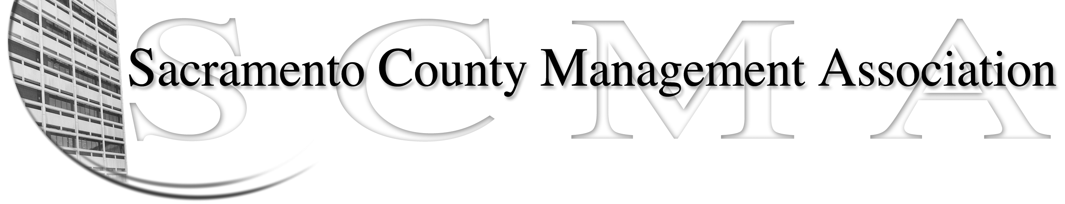

Kelsey Johnson, President Brad Buyse, Board Member
Forrest Williams, Vice President Sue Elliott, Board Member
Nancy Gust, Secretary Elizabeth Foster-Ward, Board Member
Piper Wilson, Treasurer Jan Holm, Board Member
Scotte Trudeau, Board Member

SCMA Business Meeting Minutes
Hilton Hotel
January 13, 2011

- Welcome & Introduction of New President – Mike Guiver

- Recognition of Outgoing Board Members, New Board Members & Officers – Kelsey Johnson

- Bylaws – Sue Elliott

  - Minutes to reflect that all suggestions for By-Law revisions should be sent by Association members to the Board of Directors by September 7th, 2011. They shall also reflect that committee chair names will be posted on the website.

- Introduction of Supervisor Phil Serna – Kelsey Johnson

- Raffle – Sue Elliott

- Negotiations Update – Jason Jasmine, CBM (Carroll, Burdick & McDonough LLP)

- Recruitment & Department Liaisons – Nancy Gust

- SCMA Financial Report & 2011 Budget – Mike Guiver & Piper Wilson

- Other

  - Could the website include the percent of department membership stat
  - Check and see if Benefit study is on website

10. Closed session

