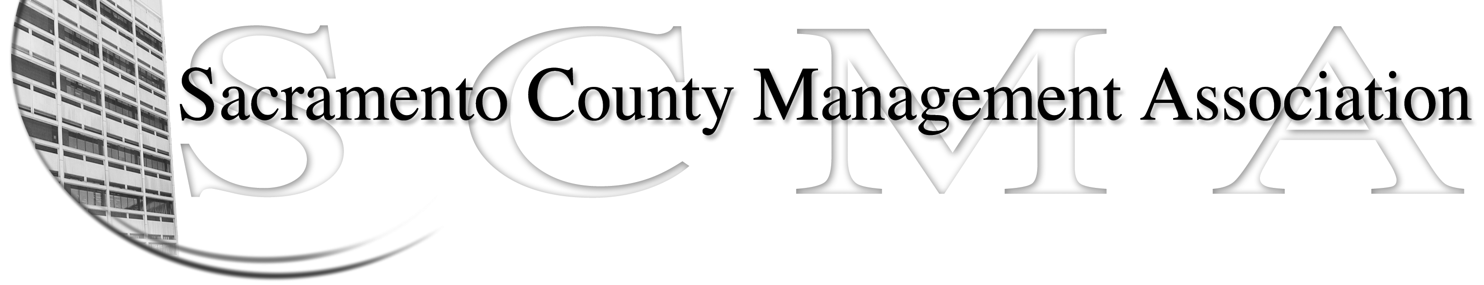

Kelsey Johnson, President Forrest Williams, Vice President
Nancy Gust, Secretary Jan Holm, Treasurer
Diana Ruiz, Board Member Darcy Moehring, Board Member Will Roman, Board Member Elizabeth Foster-Ward, Board Member Kathy Bryan, Board Member Cathy Girton, Board Member
Vacant, Board Member Vacant, Board Member

SCMA Board of Director’s Minutes
Jan 4, 2012 – 3:00 P.M.
Office Building 3 – 3701 Branch Center Road
Large Conference Room

Attendance: Jan Holm, Kelsey Johnson, Darcy Moehring, Diana Ruiz, Elizabeth Foster-Ward, Lynn Wynn (proxy for Will Roman), Kathy Bryan, Nancy Gust, Forrest Williams, Cathy Girton

Absent: Will Roman

Guests: Craig Rader, Monica Voetsch, John Hinkley

- Introductions

- Minutes: Motion: Accept as corrected the December 7, 2011 Board of Director Minutes by Jan and seconded by Elizabeth. Ayes – All

- Treasurers Report
  - Handouts – Emailed to board members

- Committee Reports
  - Association – Jan – No report

  - Bylaws –Diana/Kelsey – Review still in progress

  - Elections – Kelsey/John – Election Process & Procedures have been updated
IV. (Continued)

  - Website – Craig e-mailed website reports. He also updated the calendar through July 2012.

  - Membership – Darcy – Membership will be updated in March before Elections & LTD.

  - Discipline - Lynn – Update

  - Meet & Confer – Elizabeth – Changes to job classes in County Executive’s Office went to Civil Service on December 16, 2011. The Analyst MQ’s are still pending.

- Correspondence

- Old Business
  - Audit Committee – Monica Voetsch – The Audit Committee conducted its review. The committee made a few suggestions but reported the financial records were prepared and reported free of material misstatement.

- New Business
  - Recruitment Drive – Darcy – 23 new members. Four names to be drawn from new members and four from referrals for gift card. Winners to be contacted by Darcy to see which gift card they would prefer.

VII. Adjourn 4:45 p.m.

