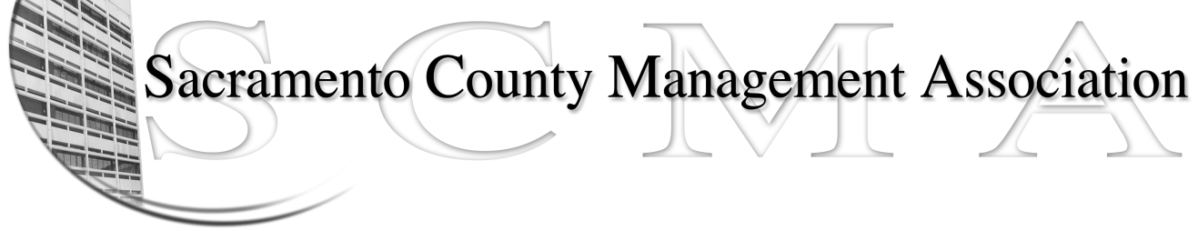

Kelsey Johnson, President Diana Ruiz, Vice-President
Jan Holm, Treasurer Nancy Gust, Secretary
Frances Worth, Board Member Darcy Moehring, Board Member
Pamela Harris, Board Member Cathy Girton, Board Member
Stephen Wallach, Board Member Kathy Bryan, Board Member
Bruce Coker, Board Member Vacant, Board Member

SCMA Board of Director’s Minutes
January 2, 2013 - 3:00 P.M.
9616 Micron Avenue, Suite 900

Attendance: Diana Ruiz, Kathy Bryan (proxy for Cathy Girton), Frances Worth (proxy for Darcy), Jan Holm, Kelsey Johnson, Stephen Wallach, Nancy Gust, Pamela Harris

Absent: Bruce Coker

Guests: John Hinkley, Jesus Cervantes

- Introductions

- Minutes: Motion: Approve December 5, 2012 Board of Directors Minutes as corrected Jan and seconded by Diana. Ayes – All

- Treasurer’s Report – Report provided

  - Audit Committee Update – Update provided. Two members had to step down from committee. Mike Guiver was appointed new chair of committee.

- Committee Reports
  - Association Meeting – No report
  - Bylaws – Sue/Diana - No report
  - Elections – Kelsey/Roberta - No report
  - Website – Craig - E-mailed
  - Membership – Darcy – No report
  - Discipline – Kathy - Report provided
  - Meet & Confer – Diana - Report provided

- Correspondence

- Old Business
  - Board of Director Insurance Update – No report
  - Audit Committee – Mike Guiver is the new Chair. Piper Wilson and Stuart Frazer are the other members

- New Business - none

- Adjourn 3:45 p.m.

- Closed Session

- Public Session – A Motion was made in Closed Session for SCMA to not oppose the unit modification request of the Probation Supervisors by Diana and seconded by Pamela. AYES – All

Adjourn 4:42 PM

